Making a lower pillion saddle for solo machines using original pillion saddle.

**Stage 1**

Remove spring from its mounting on the hanging wings on the saddle frame and detach saddle from front its front pivot mounting post. Remove hand grip from front mounting post.

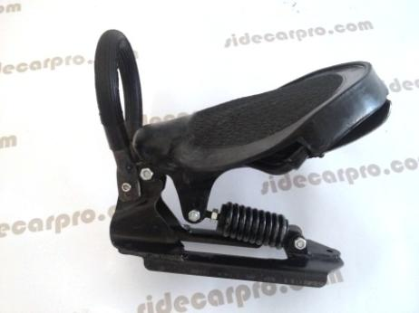

Cut off both wings of spring mount as close to saddle frame as possible as indicated by red line. Rubber saddle was left in place when I did this. Dress cut areas on saddle frame to smooth finish

**Stage 2**

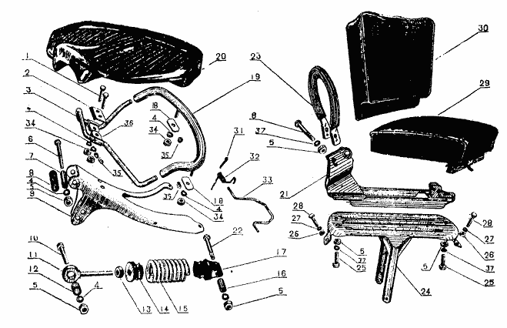

Reduce height of saddle frame pivot post by cutting across framework at approximately red line on both sides of mounting post on the saddle rack framework. Dress cut parts to smooth finish.

**Stage 3**

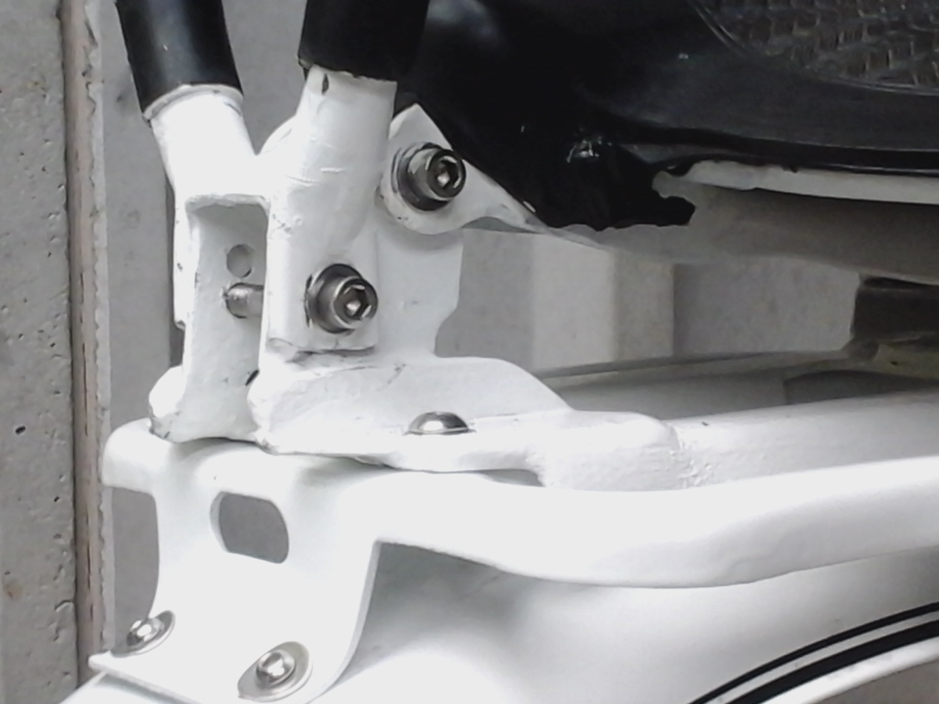

The top portion of the mount can then be inserted between the bottom section of the left on the saddle rack framework. Weld the two sections together to create lower pivot mount post. Above shows finished reduction height of front mount post. Bottom of hand grip mounting hole is just above weld line.

**Stage 4**

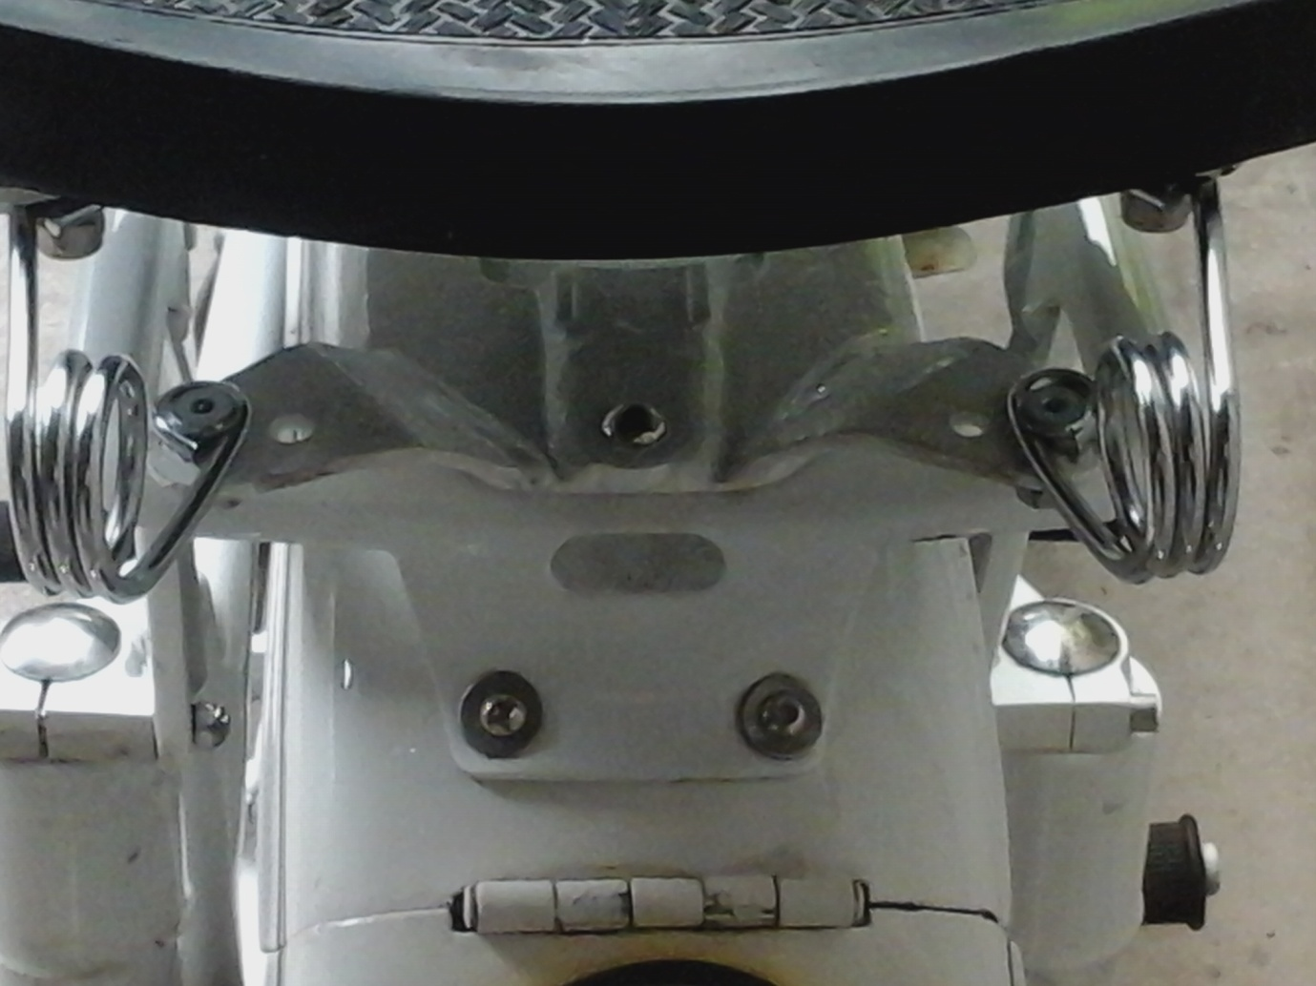

Using the two wing parts of the spring pivot, cut from the saddle frame, weld these to the frame work of the saddle rack framework to form rear spring support points. Springs used here are 3 inch Harley style saddle springs.

Stage 5

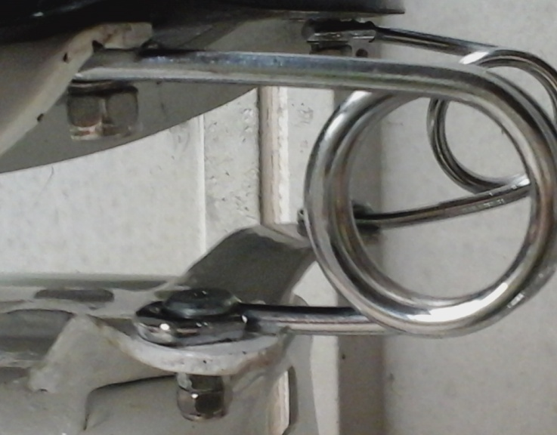

Clean up welds, paint and refit parts together. Above shows upper and lower fixing points for the saddle springs.

The finished result, an original pillion saddle with a suitable centre of gravity for the CJ solo motorcycle

