ENGINE: Front and Timing Cover Reassembly
With the timing gear on the cam, insert the rollers back into position behind the spring loaded pins. If necessary an application of grease may help hold them in place. Replace the starter gear onto the cam by gently pushing while rotating in a clockwise direction. Once in place, try turning it in both directions to check its one way action. | 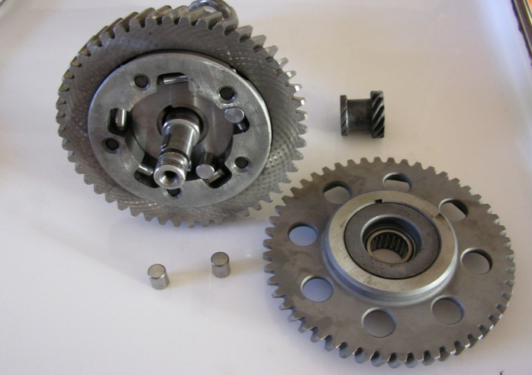
The point cam drive gear holds the starter gear in place. It is keyed in position onto the cam with an interference fit. Using the correct size socket or tube, drive the gear onto the end of the cam (heating the gear will make this task much easier). Next install the thick metal washer, and the small “O” ring. | 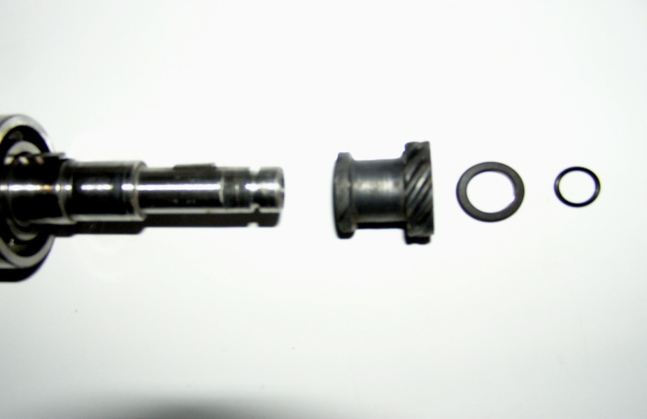
Clean the front cover and check the following before installation: 1. Thrust support/bearing for the starter motor shaft. If you have not disturbed it, it will be fine, if you have moved it, readjust it after the cover and starter motor have been installed. 2. Rubber insert for engine breather system. 3. Front cam bushing. 4. Rubber bushing/connector for the front oil gallery, make sure this is in good condition, replace if necessary. 5. Front main crankshaft seal. | 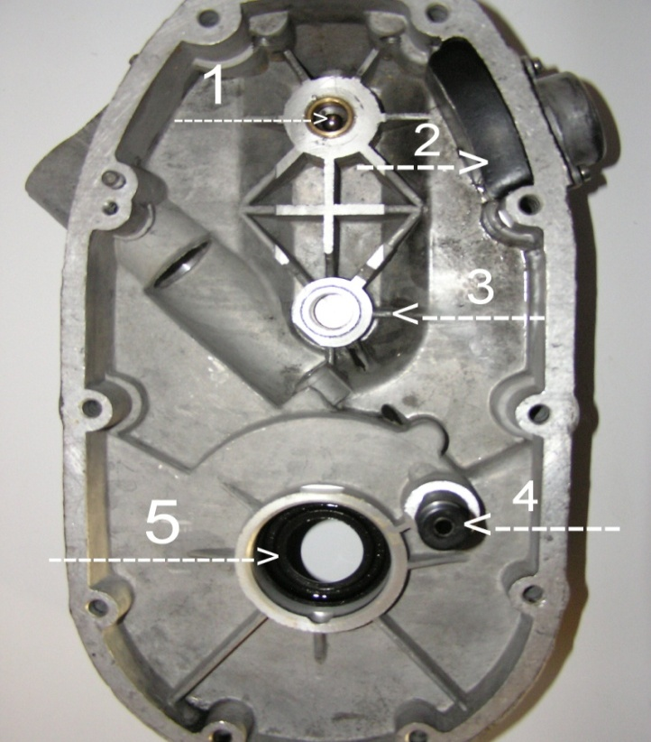

ENGINE: Front and Timing Cover Reassembly
The front crankshaft seal is a 27x47x7mm single lip design. Install with the hollow side in. It can be tapped in with a hammer or seal driver. After installing, apply grease to the lip portion of the seal. Reinstall the cover onto the engine case and secure with the nine “Allen” style bolts, and the hidden bolt from the other side. | 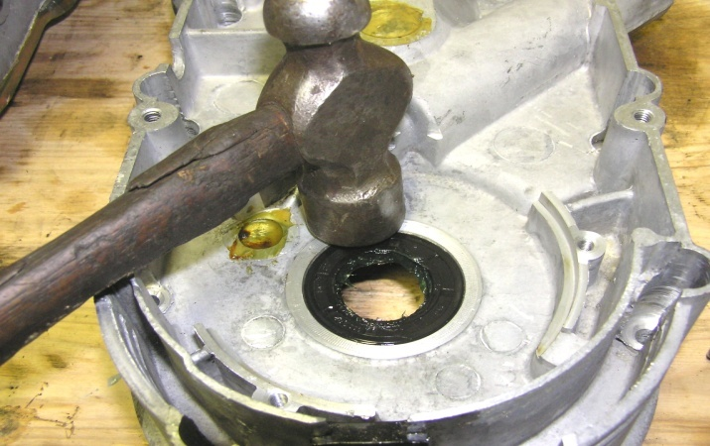
Place the rotor onto the crankshaft with a push/twist in order to engage the seal and seat it squarely on the crankshaft. Reinstall the 10x1.50x152mm rotor center bolt and tighten securely, taking care not to over tighten and break the bolt. | 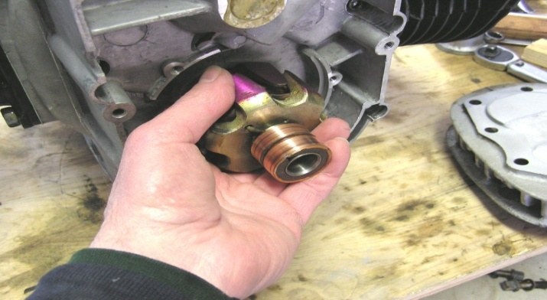
When reinstalling the stator housing take care not to damage the rotor brushes. They can be easily compressed with finger tips or small screwdriver. | 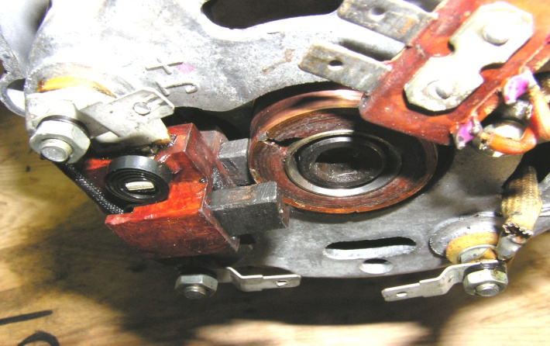
Secure the stator housing with the three 5x0.8x45mm screws. If the engine is presently in the bike frame you can reattach the wires from the wiring harness to the alternator. The last thing will be to reinstall the front cover and secure it with the two 6x1x32 bevel headed screws. | 