TRANSMISSION: Disassembly
After transmission removal from the engine, if you have not already removed the kick start and clutch throw-out levers do so now. The kick start lever bolt is actually a wedge shaped pin that must be driven out. Leave the nut on the end of the bolt to protect the threads as you tap it loose with a hammer. | 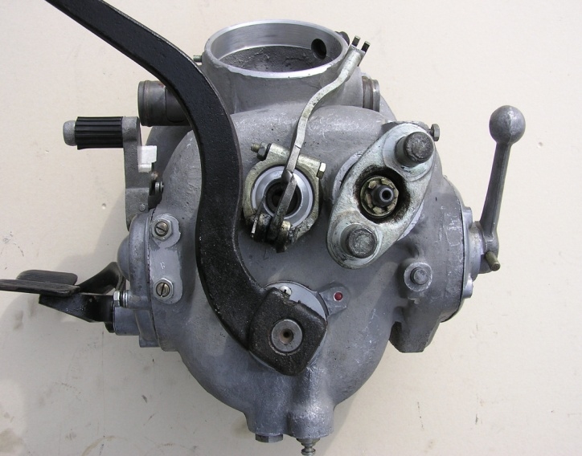
After removing the cotter pin, use a 19mm socket to remove the nut that secures the drive shaft flange to the transmission output shaft. With the nut removed the flange can be pulled from the end of the shaft. | 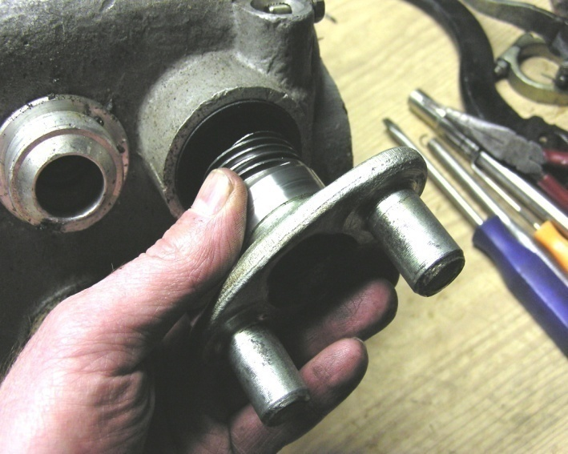
Remove the shifter ratchet mechanism by removing the four 6x1x28mm bolts with a 10mm wrench / socket. Next remove the reverse gear selector lever by removing the 8mm nut (thread is 5x0.8mm) and driving the wedge bolt out. | 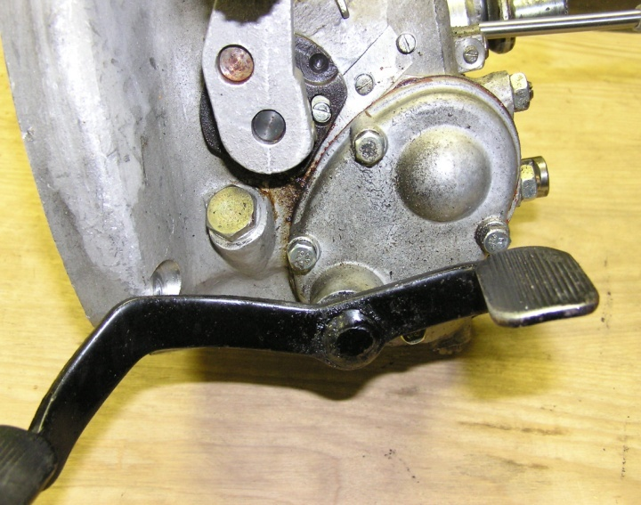

TRANSMISSION: Disassembly
On the right side of the transmission remove the hand shift lever by removing the 8mm nut ( thread is 5x0.8mm) and driving the wedge bolt out. Then remove the right side access panel by removing the six 6x1x10mm bevel headed screws. | 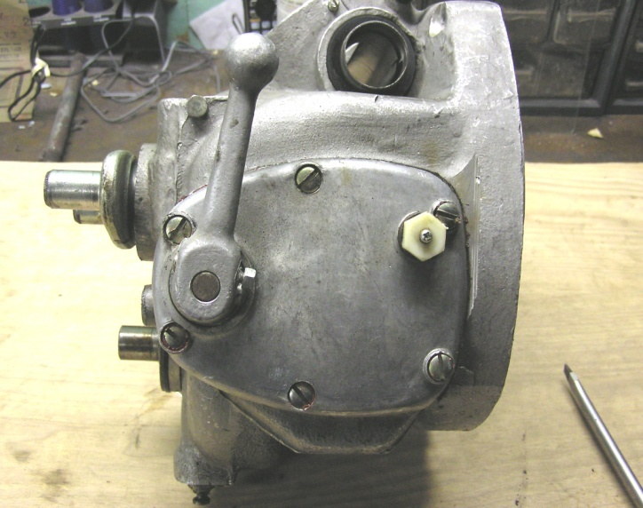
The gear shifter shaft/cam plate can now be withdrawn from the transmission, however, the left end of the shaft is engaged in part of the reverse gear selector mechanism. It may be necessary to tap the shaft out from the left side of the transmission (see next photo). | 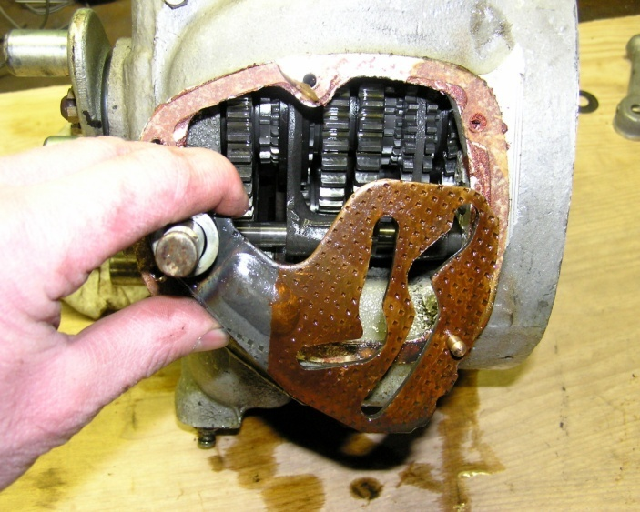
The shift shaft will get hung up in this plate and will need to be tapped through (also remove tube shaped spacer from this end of the shaft). Leave the plate for now as it is pinned in by the reverse gear shift fork and will not fall out. | 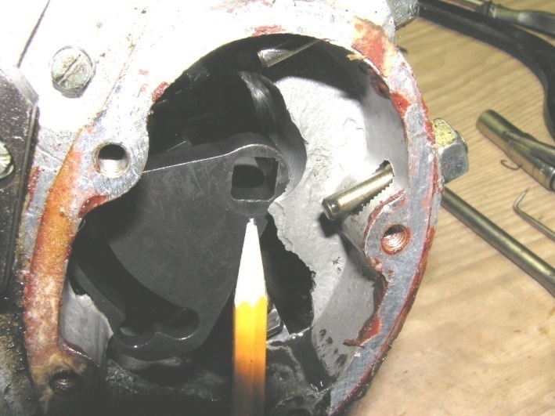

TRANSMISSION: Disassembly
There are two shift fork guide shafts, each one is secured in place by a 6x1x15mm set screw on the back of the transmission case. Take the screws all the way out as they are pointed and engage grooves in the guide shafts. | 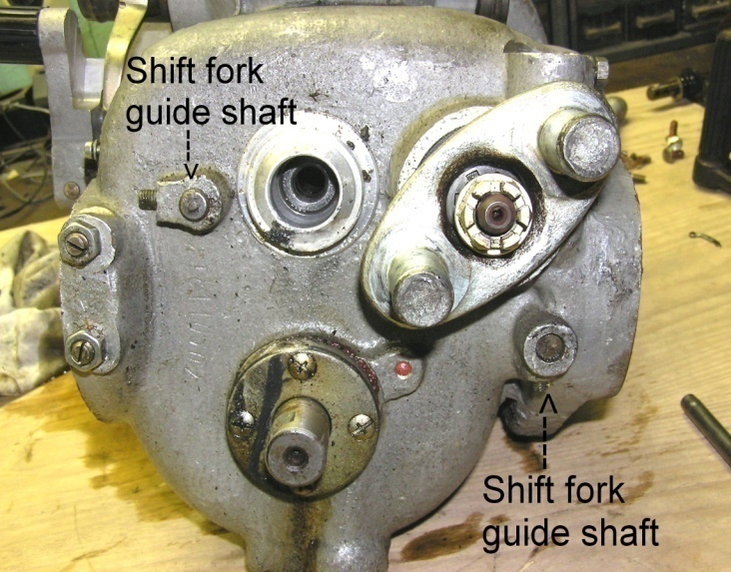
Locate the shafts in the front panel, using a hammer and punch, drive them in towards the back of the transmission. The reverse gear shift fork guide shaft (right side in photo) need only be driven in approximately one inch (25mm) at this time. Note the guide shafts have a tight interference fit and may need several firm blows to move them. | 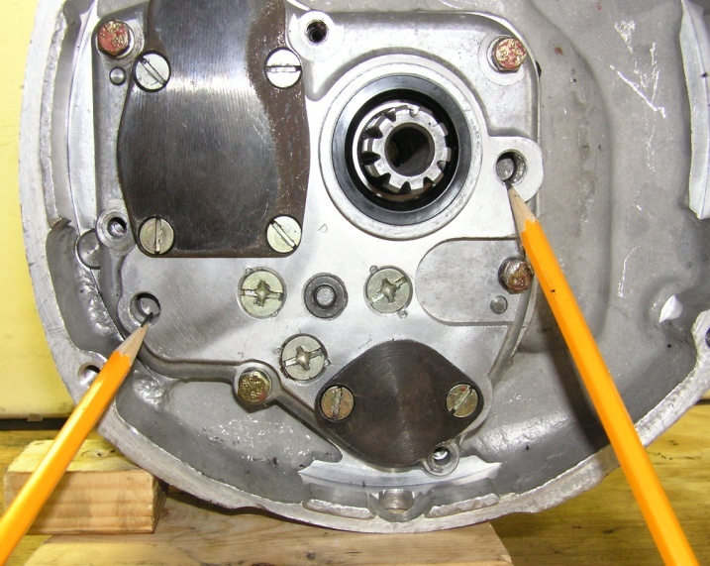
Drive the 1st-- 4th gear shift fork guide shaft all the way out and remove the shift forks. | 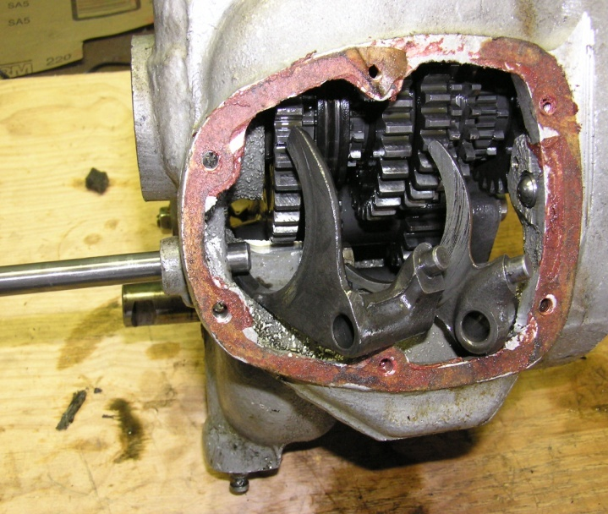

TRANSMISSION: Disassembly
Release the tension of the kick start shaft return spring by removing the two 6x1x20mm bevel headed screws from the kick start shaft end support.  The support will want to rotate a little more than half a turn in the clockwise direction. With the spring tension released the support can be removed. The spring may or may not come out with the support. | 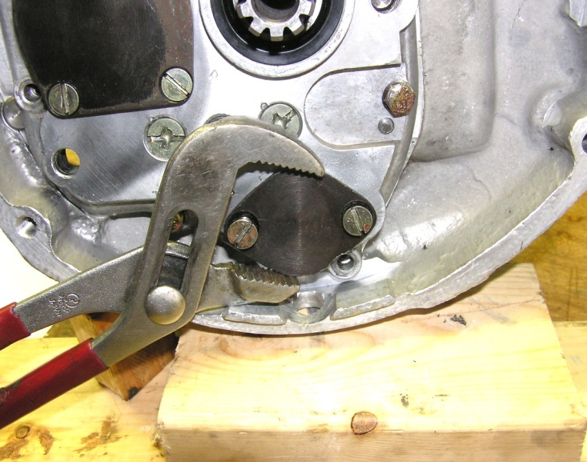
To pull the access cover, use a 10mm socket to remove the seven 6x1x25mm bolts. Then use a screw driver to remove the three 8x1x25mm bevel headed screws, and the four 6x1x13mm bevel headed screws holding the plate over the output shaft bearing. | 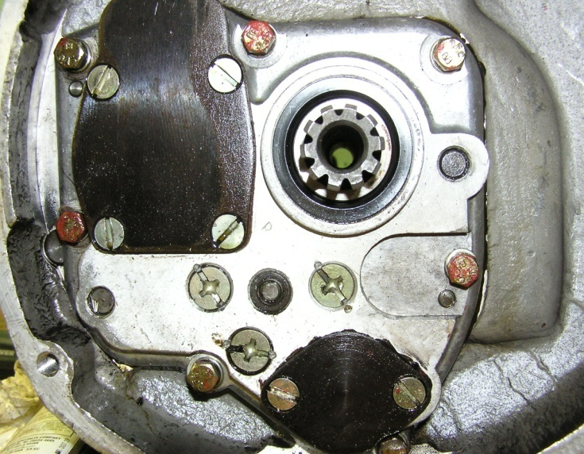
The bearings fit tightly in the access panel, and tightly on the transmission shafts, and because the access panel is recessed back from the edge of the case it is somewhat difficult to remove. Consider using a puller set up like this. Work slowly, tap the other shafts in as the panel lifts, and pry the right side of the panel in order to draw it off evenly. | 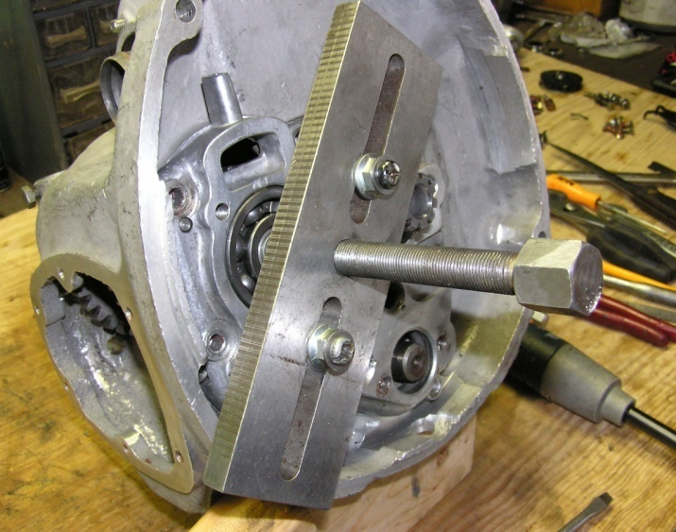

TRANSMISSION: Disassembly
As the panel is removed one or both bearings may stick on the shafts or remain in the panel. | 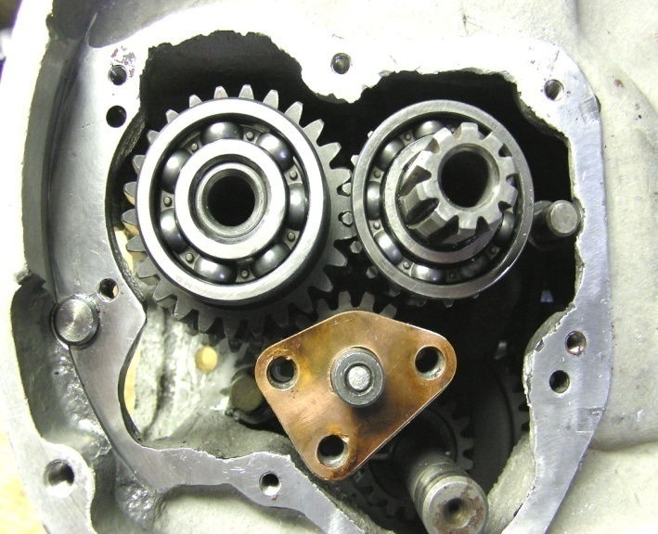
Turn the transmission on its left side and pull the output shaft out of the transmission leaving behind the gears, the only thing that will fall into the case is the large flat thrust washer on the back end of the shaft. The individual gears can now be removed and set aside. | 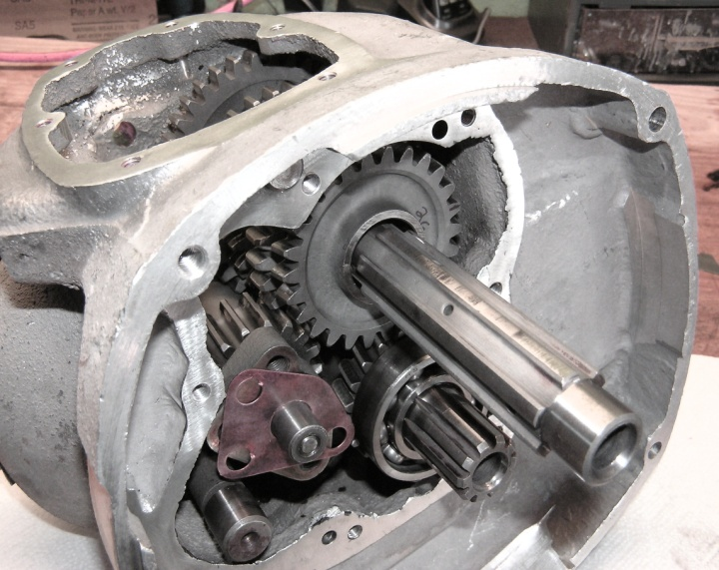
The next step is to remove the two 6x1x17mm bevel headed screws from inside the air box area of the transmission case. These screws anchor the top end of the reverse gear jackshaft support bracket inside the case. | 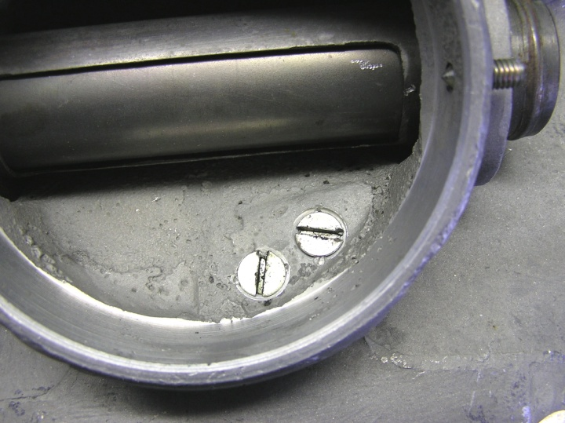

TRANSMISSION: Disassembly
Back inside the transmission case unbend the lock tab washer and using a 13mm wrench remove the 8x1x20mm bolt securing the other end of the reverse gear jackshaft support bracket. | 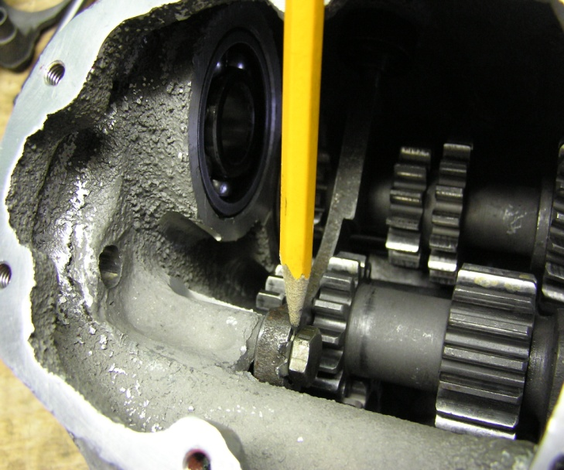
With the screws and bolt removed the reverse gear jackshaft can now be removed. | 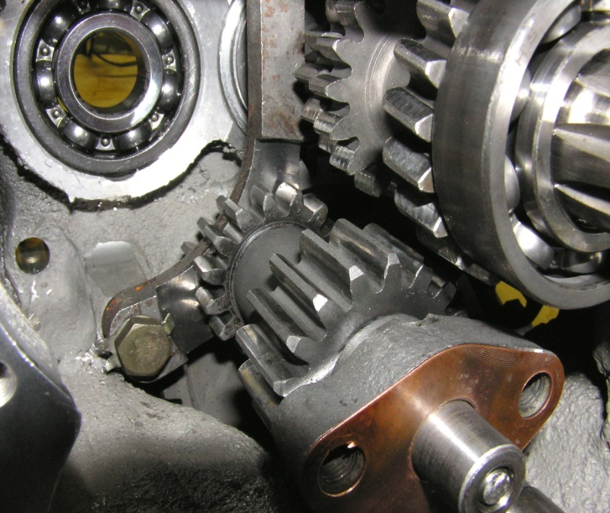
Next pull the input shaft out of the case. There are no washers to fall off and it will remain intact. | 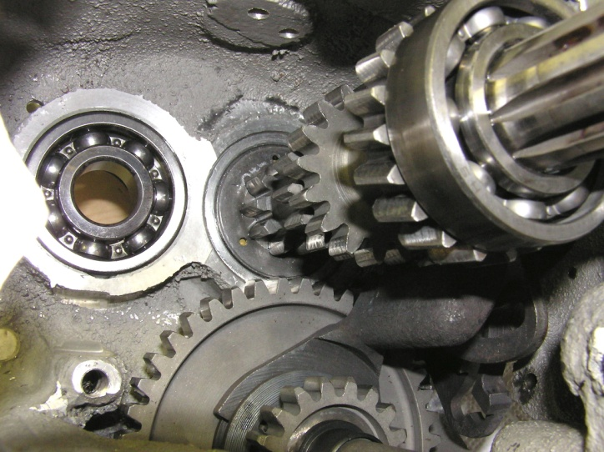

TRANSMISSION: Disassembly
Finish driving the reverse gear shift fork guide shaft out of the transmission case. In order to get enough movement to remove the reverse gear shift fork and shift cam plates it will be necessary to remove the kick start shaft support bushing from the back of the transmission case. | 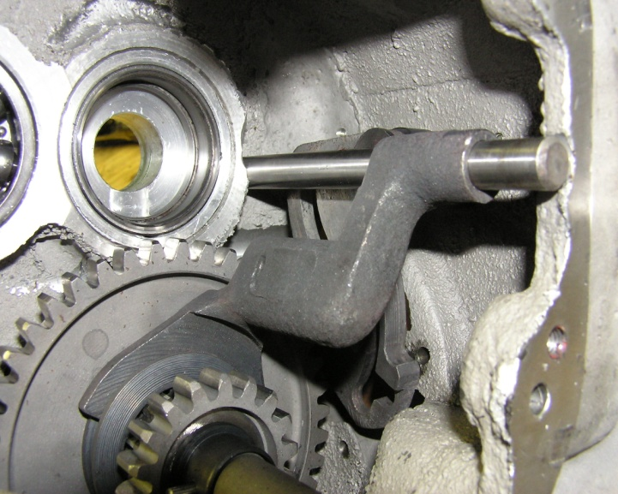
The kick start shaft support bushing, seal, and seal cover are secured by four 5x0.8x17mm screws. With the screws removed the bushing can be pulled off the end of the kick start shaft. It will help if the other end of the kick start shaft is supported. | 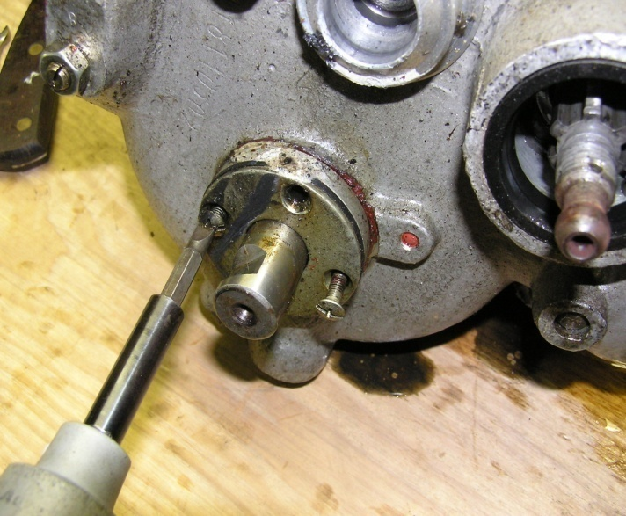
With the reverse gear parts and kick start shaft bushing removed from the case the complete kick start shaft can be pulled out of the transmission case. | 