TRANSMISSION: Reassembly
Before reassembly you may want to degrease the transmission case. There are a variety of commercial degreasers or solvents available that will make this job easy. | 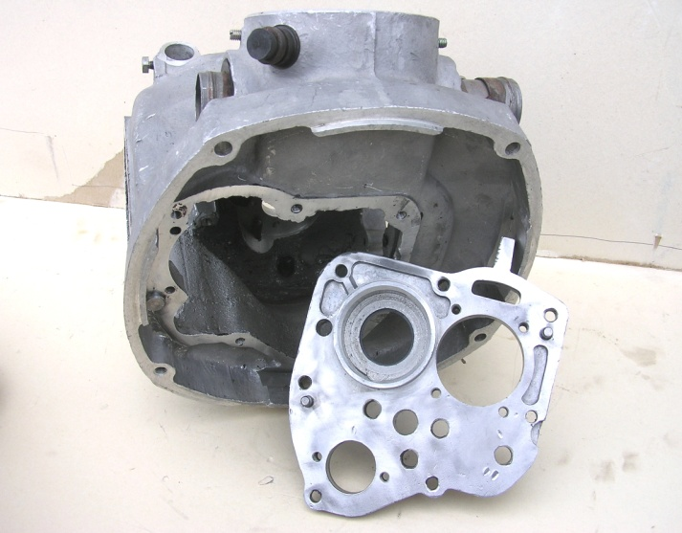
Scrape off all old gasket material and clean all gasket surfaces. | 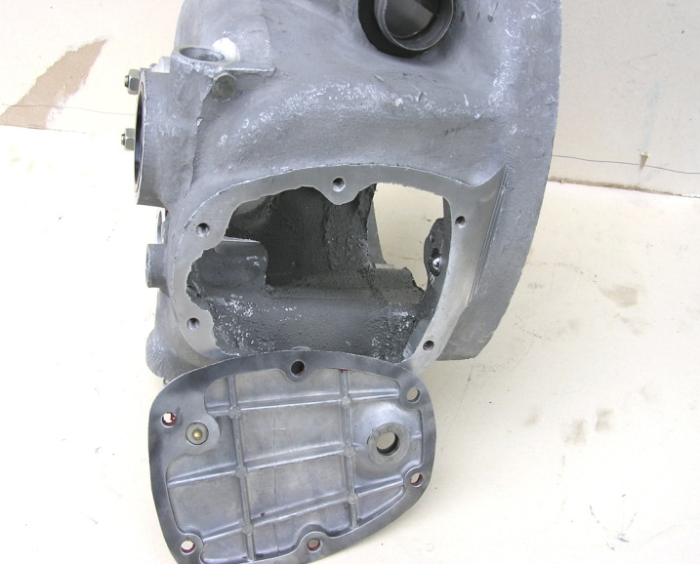
Insert the assembled kick start shaft into the case. Push it all the way back and turn it to the left till it hits its stop. | 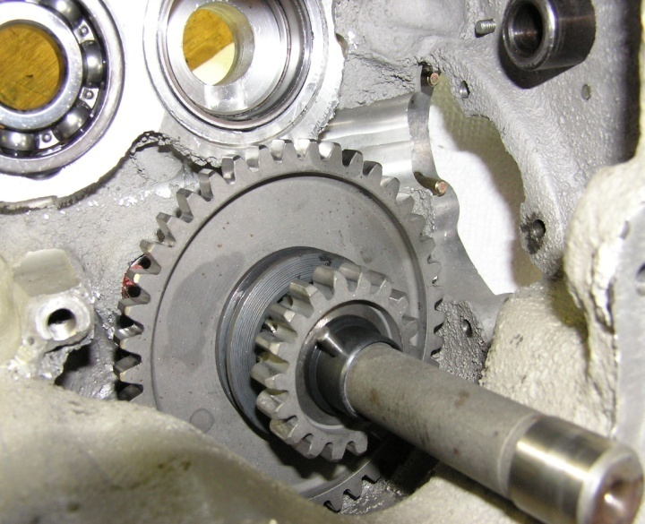

TRANSMISSION: Reassembly
Assemble the reverse gear shift fork and associated shift cam plates. Install them into the transmission case. It’s a tight fit and may take some wiggling. | 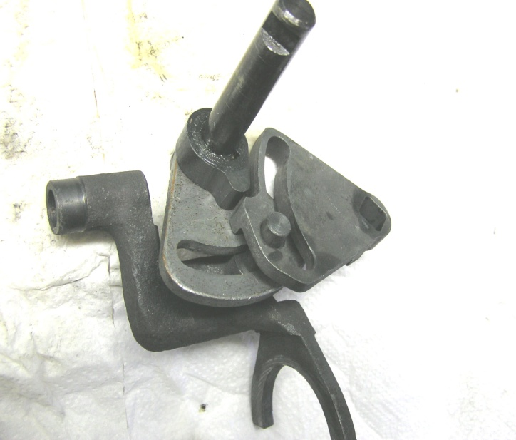
With the reverse shift fork and shift cam plates installed slide the reverse gear shift fork guide shaft into its hole. At this point leave about one inch (25mm) sticking out the back of the transmission case. | 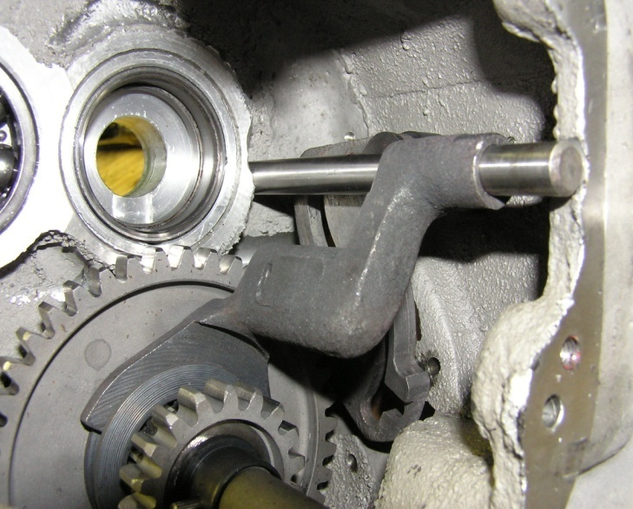
Install the kick start shaft bushing onto the kick start shaft and into the transmission case (use a new gasket if needed). Then install the seal (use new seal if needed) and seal cover, then secure with the four 5x0.8x17mm bevel headed screws. Take care not to over tighten and ruin the seal. Use of a thread locking agent is recommended. | 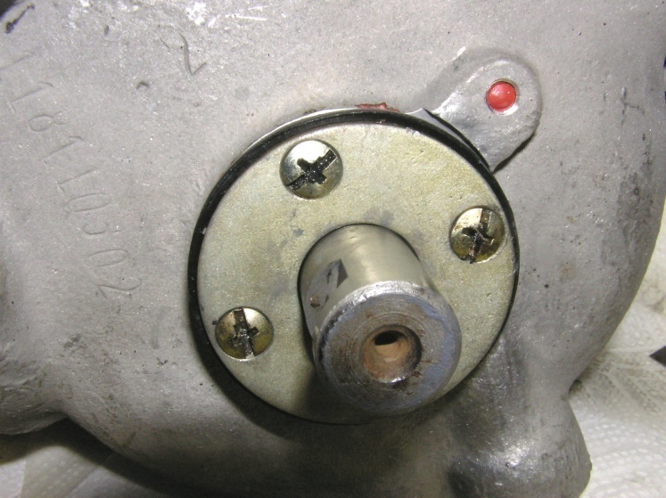

TRANSMISSION: Reassembly
Apply some grease to the input shaft roller bearing and insert the shaft into place. | 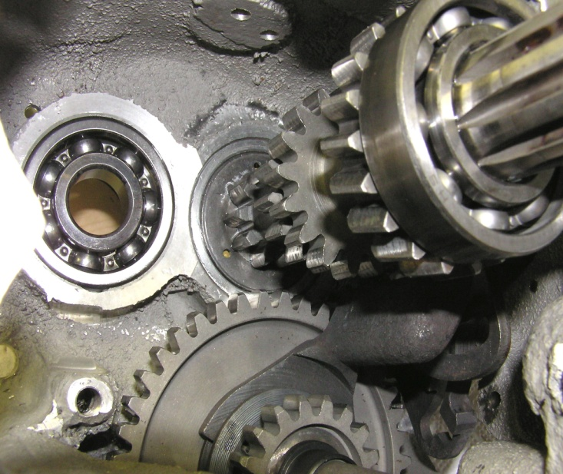
Install the reverse gear jack shaft securing it with the two 6x1x17mm bevel headed screws from the top of the transmission case, and the one 8x1x20mm bolt in the bottom of its bracket (bend tabs of the locking tab washer). Note copper gasket on front of jack shaft, make sure that it is in place and properly oriented. | 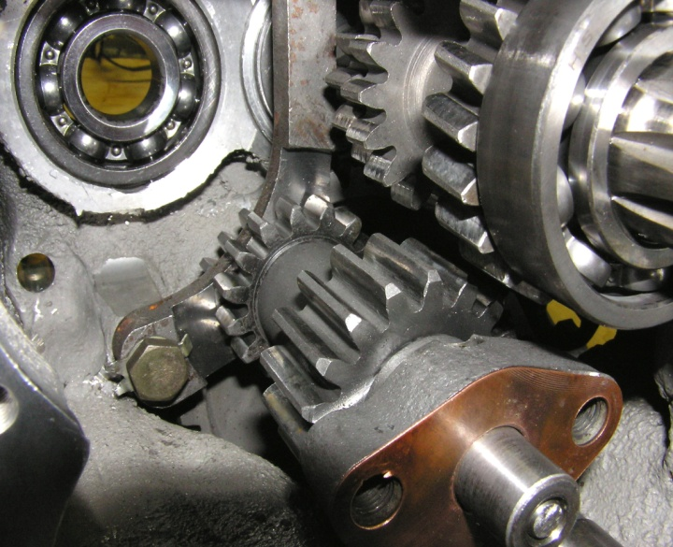
Roll the transmission onto its left side. Place all the output shaft gears into the case in proper order. | 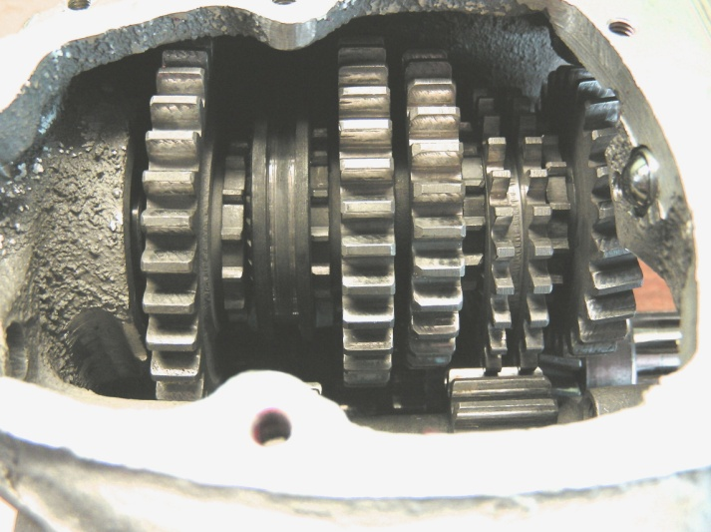

TRANSMISSION: Reassembly
With the output shaft gears in the case feed the output shaft in through the gears. Don’t forget to insert the larger flat thrust washer between the last gear and shaft bearing as the shaft is being pushed through. | 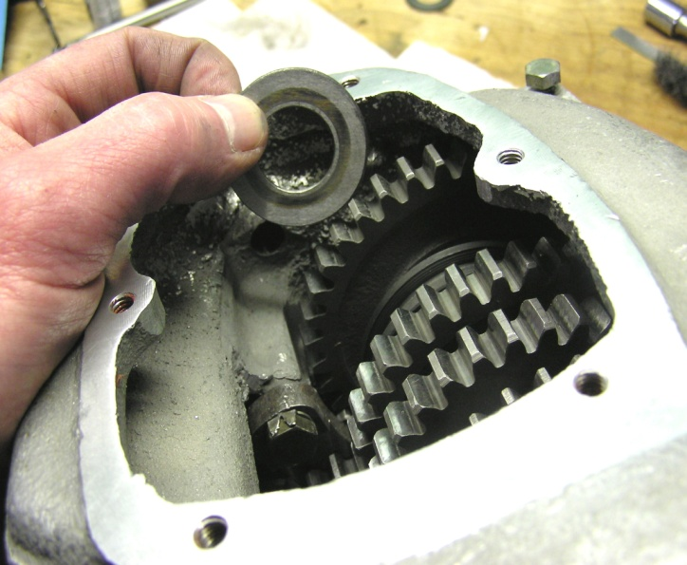
With both shafts in place make sure they turn freely. Note you may not be able to fully rotate either shaft unless you have moved the output shaft gears into the neutral or a single gear position. | 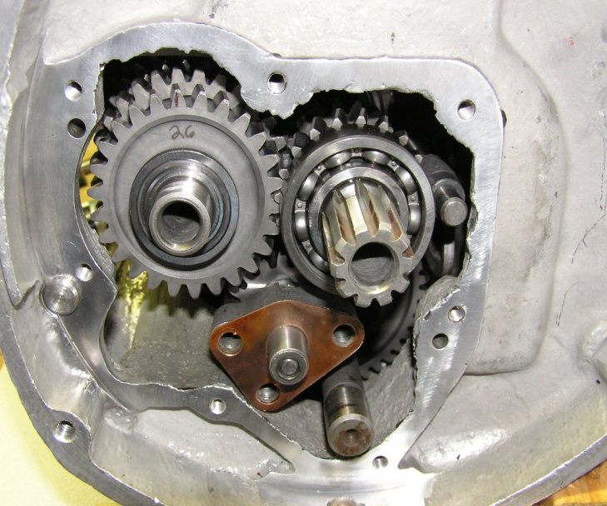
With a new gasket (if needed) install the front access panel. Tap it down at first. Make sure it is going on straight. If the input shaft seal is already in place you may have to ease its lip over the edge of the shaft. Once tapped down far enough start the seven 6x1x25mm bolts and the three 8x1x25mm screws. Use the 6mm bolts to evenly draw the panel on. Secure all related screws and bolts. | 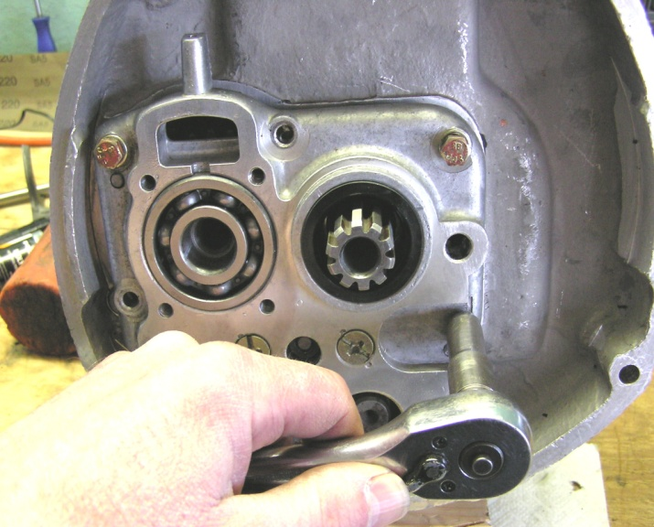

TRANSMISSION: Reassembly
As you are tightening the front panel the shafts may start turning tightly. If so, use a suitable drift pin and mallet to give a sharp rap to the end of the shafts. This will relieve side pressure on the shaft bearings, the shafts should now rotate freely (again assuming proper gear position). | 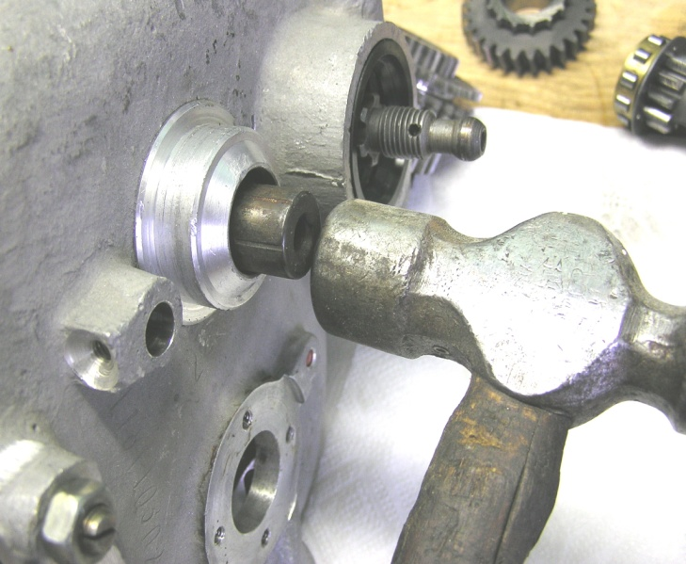
With a new gasket (if needed) insert the kick start return spring and end cap. Engage the hook of the spring on its anchor pin (you can visually check this through the left side hole of the transmission case). | 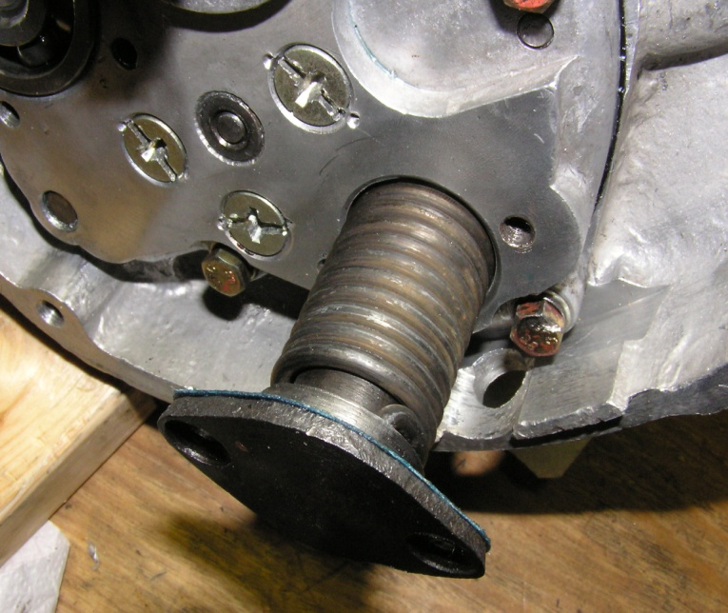
You will need to wind the end cap counter clockwise just over one half a turn, then while holding the cap in place secure it with two 6x1x20mm bevel headed screws. | 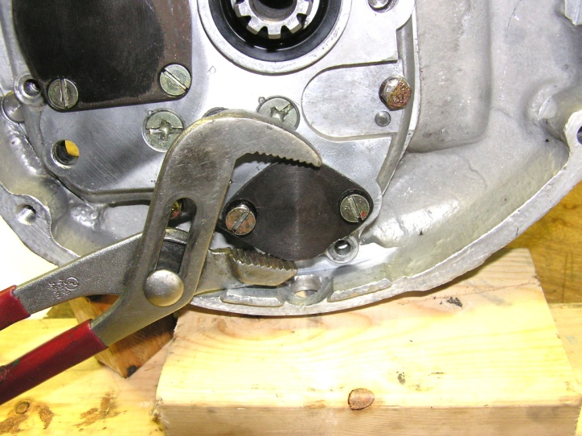

TRANSMISSION: Reassembly
Install the shift forks onto the output shaft in their proper places. Next insert the shift fork guide shaft. | 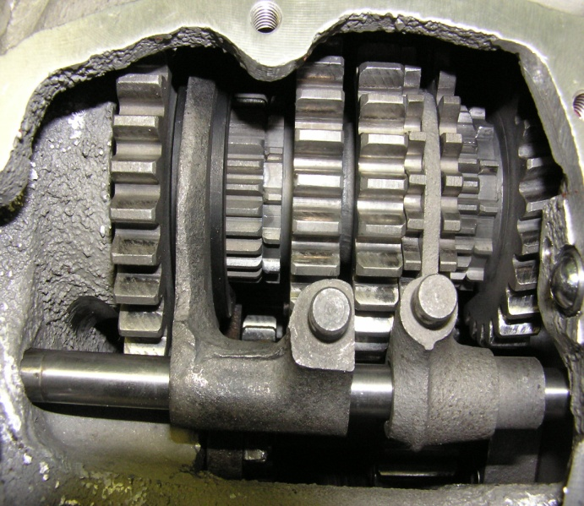
At this point both shift fork guides shafts can be driven fully into place. Note position of the set screw grooves as you drive them in, try to align the shaft grooves with the set screw holes. Finish by securing the shafts in place with the two 6x1x15mm pointed set screws. | 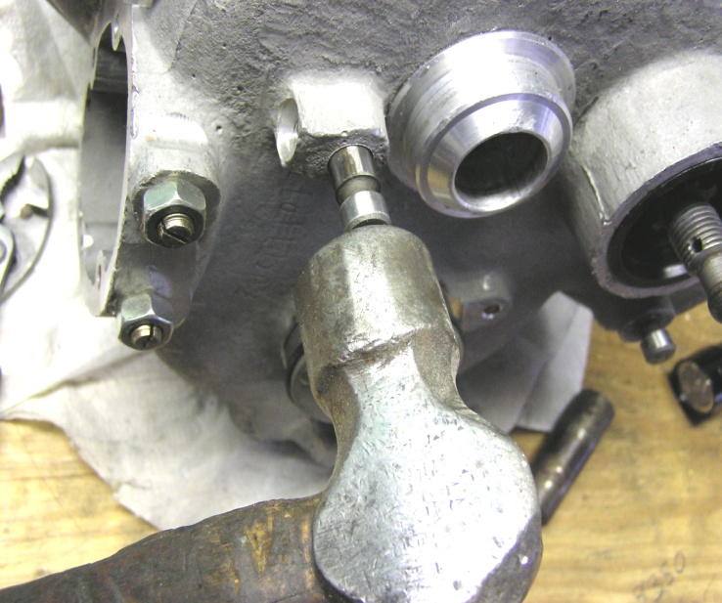
Install the shift shaft/shifter cam plate. Remember to engage the left end of the shaft into the square hole of the reverse gear cam plate on the other side of the transmission case. | 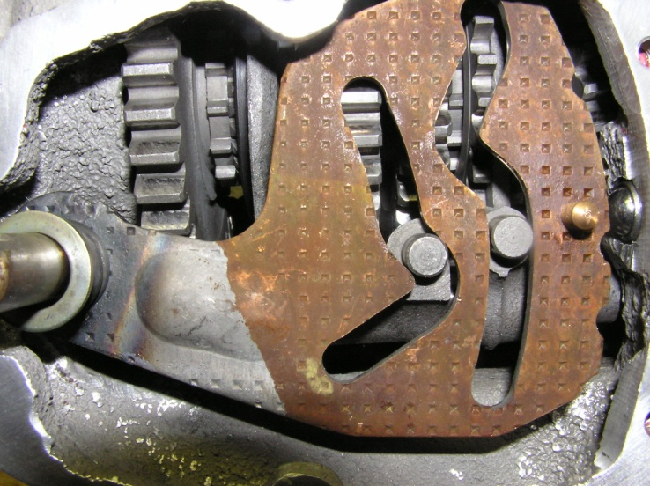

TRANSMISSION: Reassembly
Install the shift cam cover plate with the six 6x1x10mm bevel headed screws. To ease screw hole alignment it may be necessary to hold forward pressure on the cover to compress the shift detent spring. To ease shift handle installation it may be necessary to pry the shift shaft towards the right (do it from the left side of the case) to compress the shift shaft spring. | 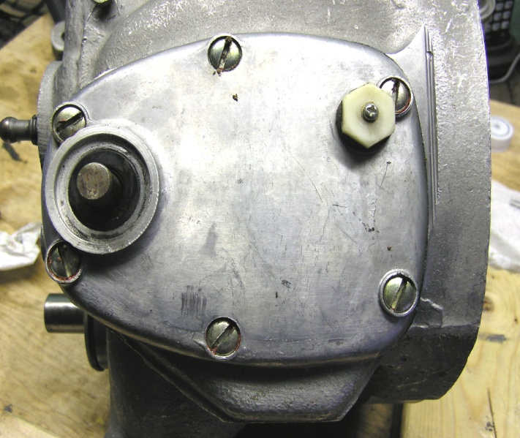
Install the reverse gear shift handle securing it with the wedge bolt and 8mm nut (5x0.8mm thread). Make sure the small tube spacer is on the end of the shift shaft before installing the ratchet shifter mechanism (with new gasket if needed). Secure the mechanism with the four 6x1x28mm bolts. | 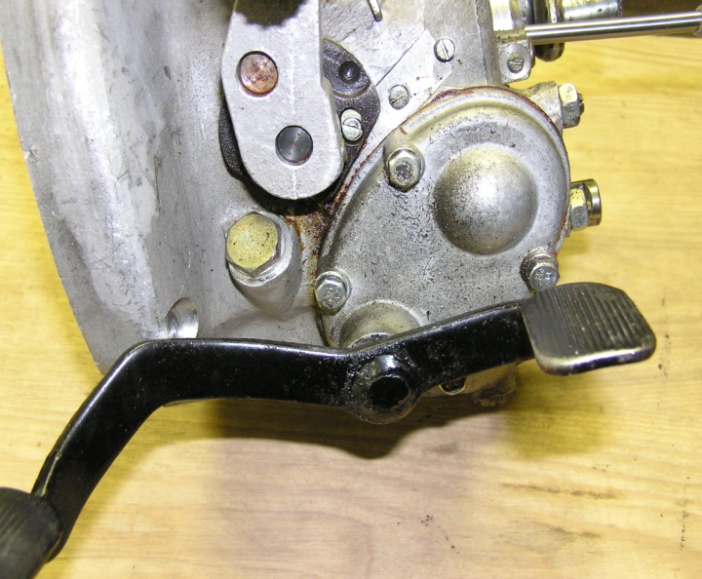
Install the output shaft flange onto the end of the output shaft and use a 19mm socket wrench to secure the holding nut. If a thread locking agent was not used consider replacing the cotter pin in this nut. | 