TRANSMISSION: Inspection
The front access panel holds the front bearing and seal for the input shaft, and the front bearing for the output shaft. Inspect the bearings for smooth operation and tightness. Inspect the seal for wear and flexibility.  The front input shaft bearing is 6205.  The front output shaft bearing is 6304.  The input shaft seal is a single lip style 31x45x7mm. | 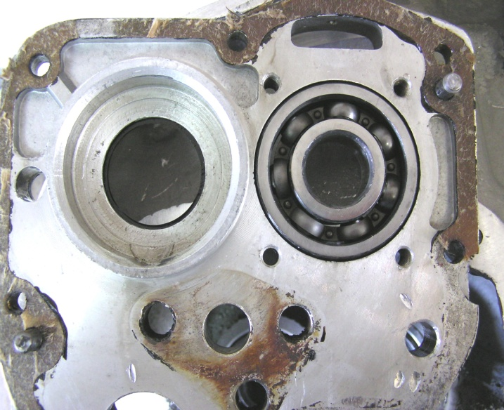
The rear input shaft bearing is a roller style bearing 12204H | 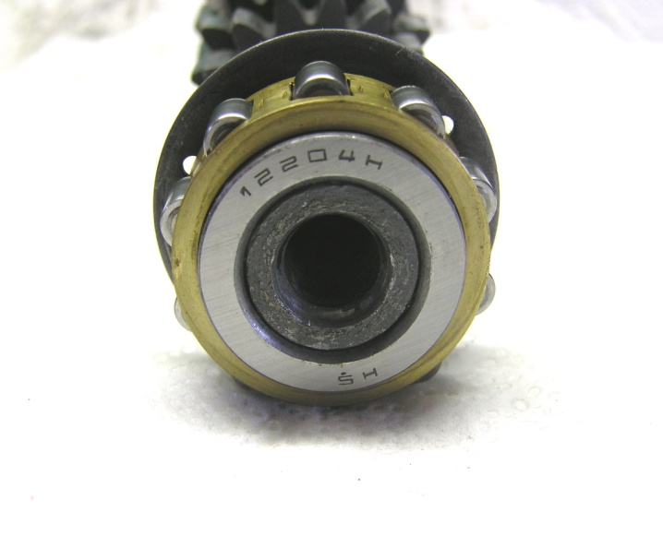
The rear output shaft bearing is 6304.  The rear output shaft seal is a single lip style 33x48x8mm. The rear input shaft bearing has a ring style outer race pressed into the case. It may be necessary to use some sort of slide hammer to pull it if replacement is needed. | 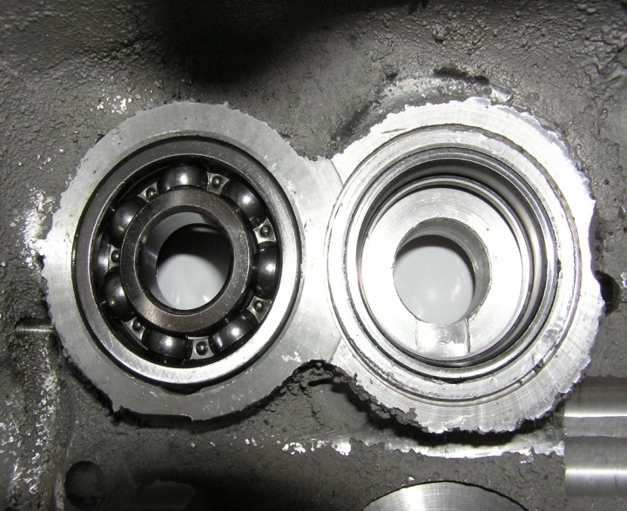

TRANSMISSION: Inspection
First, second, and third gears of the input shaft are part of the shaft. The stock 20 tooth fourth gear is pressed onto the shaft and located with a woodruff key. | 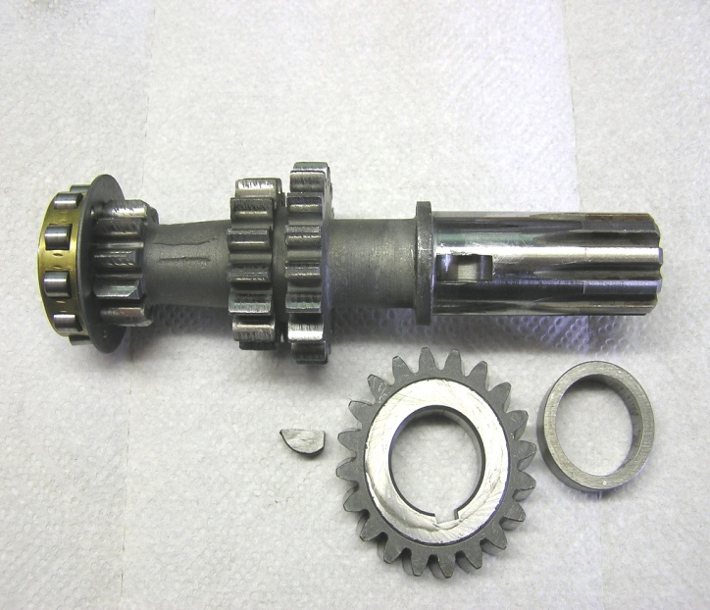
All shifting takes place on the output shaft. Gears first through fourth freewheel on the shaft, when shifting the shift forks slide the sleeve onto the side teeth of the gear locking it to the shaft. | 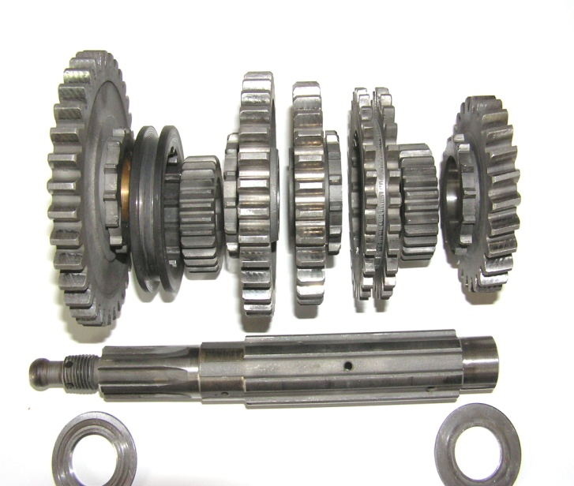
The gears first through fourth on both shafts are always engaged and turning. When you hear grinding while shifting what you hear is the side teeth of the gear trying to mesh with the splines inside the sleeve. Check this area for wear. | 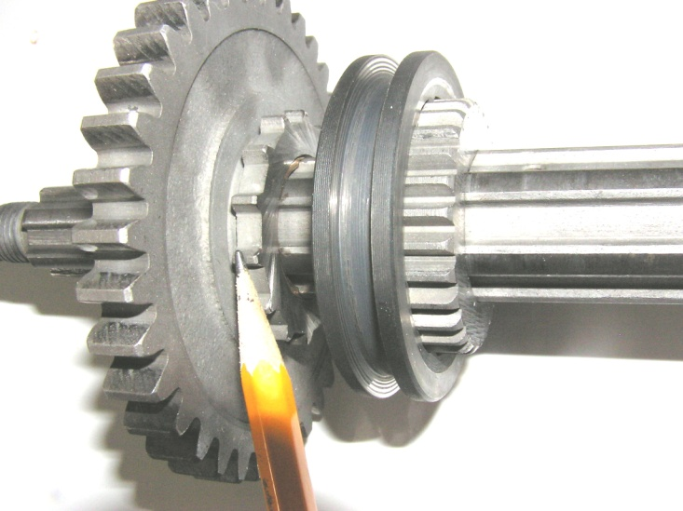

TRANSMISSION: Inspection
This is the assembled output shaft in neutral position. Note helical (slanted) teeth of fourth gear and toothed sleeve between third and fourth gears. That sleeve transmits power from the reverse jackshaft to the output shaft. | 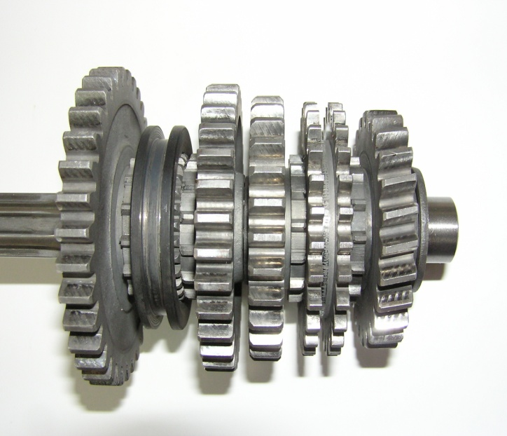
The kick start shaft can be disassembled by driving out the kick start return spring anchor pin, note that it sticks further out on the right side of the shaft. | 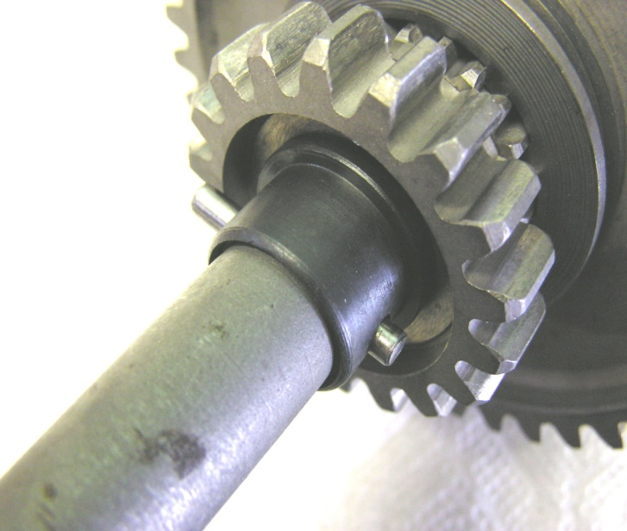
Both the kick start gear and the reverse gear ride on Un-caged roller bearings, be careful as you pull the gears from the shaft. | 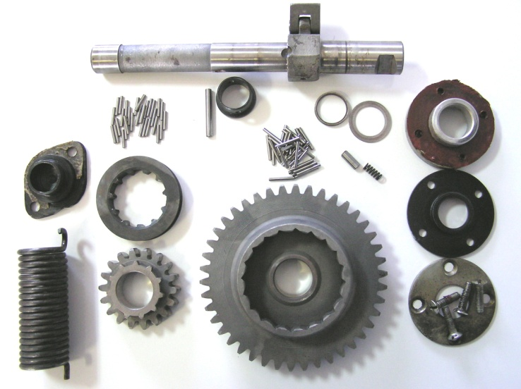

TRANSMISSION: Inspection
Make sure the top edge of the kick start pawl is in good condition, replace it if necessary. Next install the thin washer on the shaft, then apply a layer of grease to hold the 31 needle bearings to the shaft until you place the kick start gear back on. After the kick start gear install the ring shaped washer. Note, the kick start gear uses the longer needle bearings. | 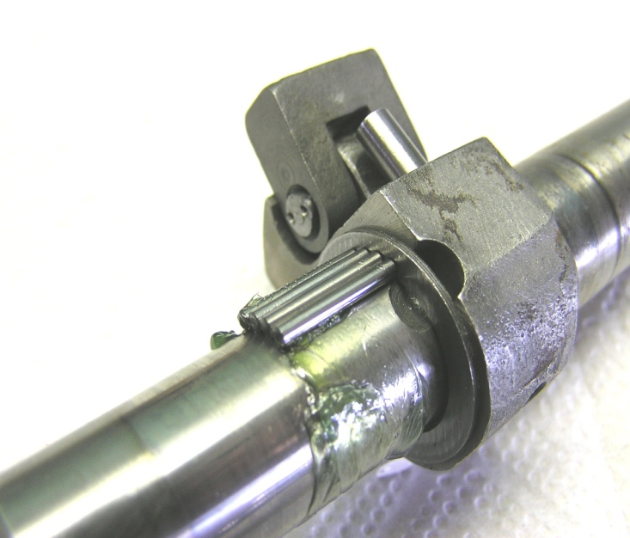
Apply another layer of grease and load the reverse gear needle bearings onto the shaft. Next install the reverse gear sleeve, reverse gear, and the collar, finish by driving the anchor pin back into the shaft. | 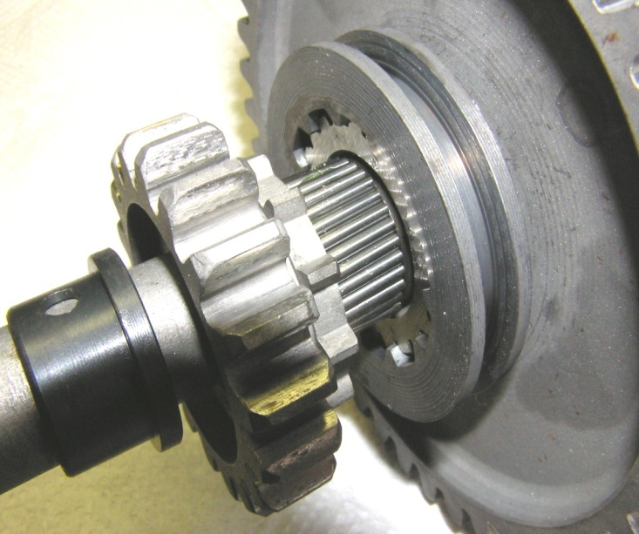
The reverse gear jackshaft has a bushing and needle bearings inside, check to see that they turn smoothly. If you disturbed the knob on the mounting bracket or are installing a new part you will want to readjust the knob. | 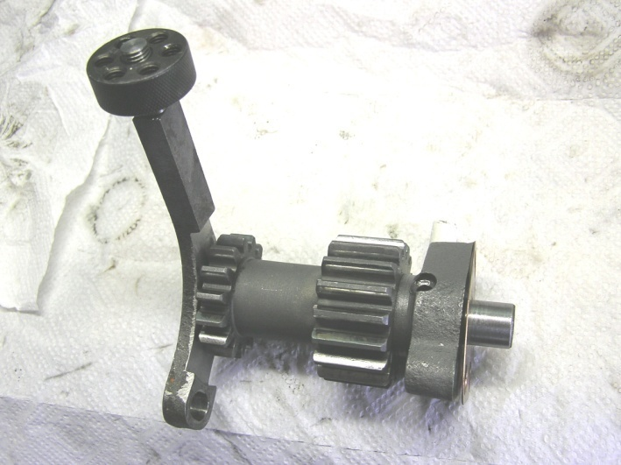

TRANSMISSION: Inspection
Temporarily attach the reverse gear jackshaft back on to the front access panel. Temporarily attach the access panel back on to the transmission case. | 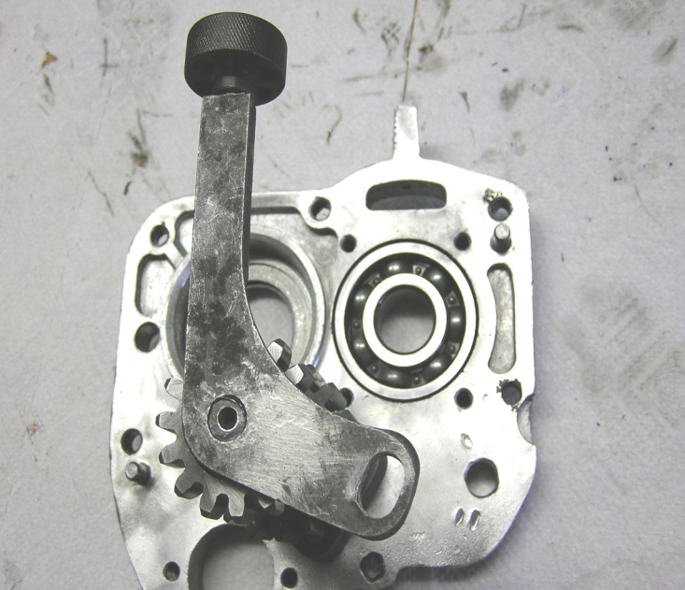
Through the right side access hole loosely reattach the bracket with the 8x1x20mm bolt on the bottom. Then lightly adjust the bracket knob against the top of the transmission case. Temporarily install the two 6x1x17mm bevel headed screws from the top to make sure the holes line up. You may want to mark the knob in case it gets moved again, or, apply some thread lock to stick it in place. | 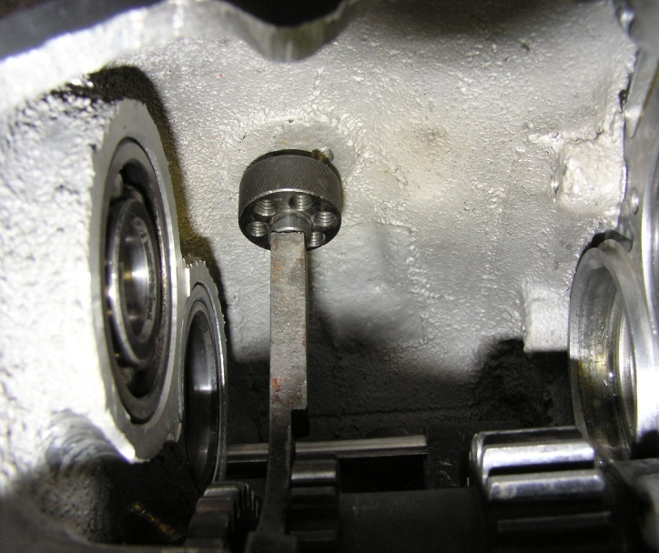
Check the shift forks for obvious wear, if excessive replace them. | 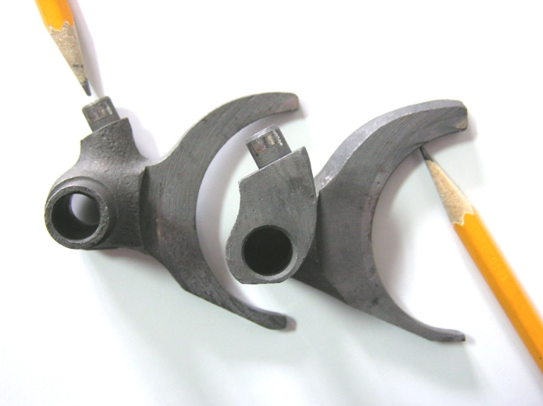

TRANSMISSION: Inspection
Check the gear shift ratcheting mechanism for looseness and wear. If you are going to disassemble it, scribe a line across the end of the bolt and the action arm so that you will be able to replace the foot lever in the same position. The toothed ratchet wheel must also be replaced in the same position. | 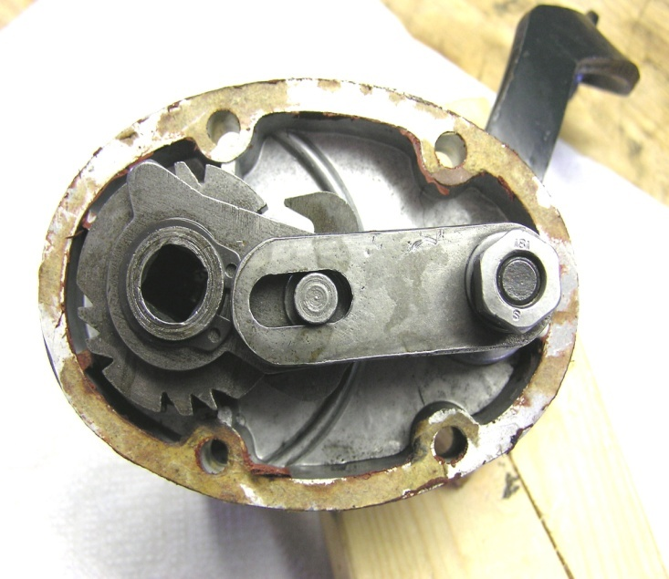
With the nut and circlip removed the ratchet mechanism is easily disassembled. | 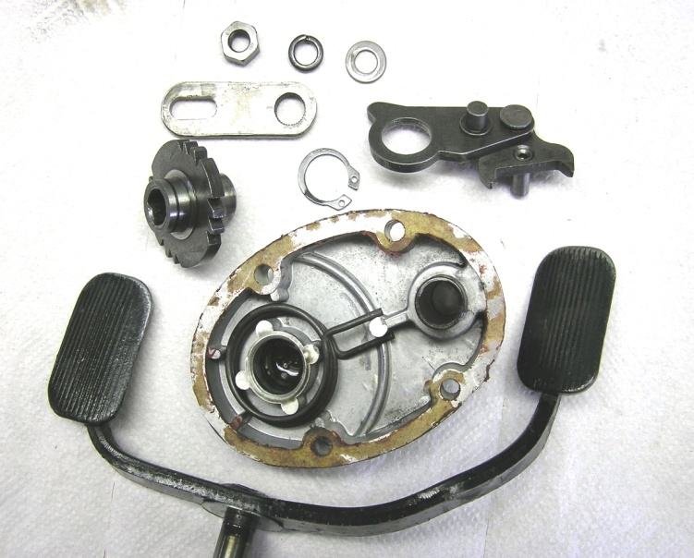
The ratchet pawl is a built up piece held together with pins “swedged” in place. If either pin has become loose you can re-peen them, or tack weld them into place. | 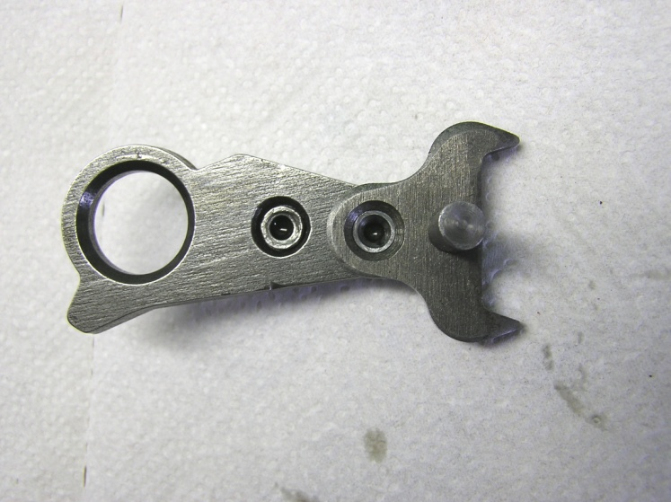

TRANSMISSION: Inspection
The ratchet wheel must be reinstalled in the same position. However, it can be rotated 180 degrees in order to provide fresh notch surfaces if necessary. | 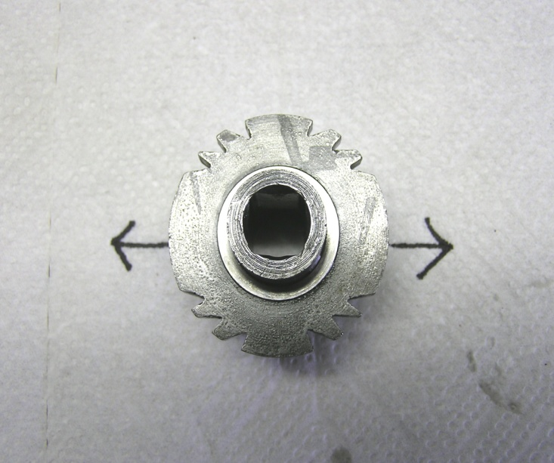
The “throw” of the ratchet mechanism can be adjusted. Up shifting (too much or too little) is controlled by the lower pin. Down shifting (to much or too little) is controlled by the upper pin. If you are over shifting (going through desired gear) turn the pin in. If you are under shifting (not quite getting into the desired gear) turn the pin out. If adjustment is needed do so in small increments (1/8—1/4 turns) | 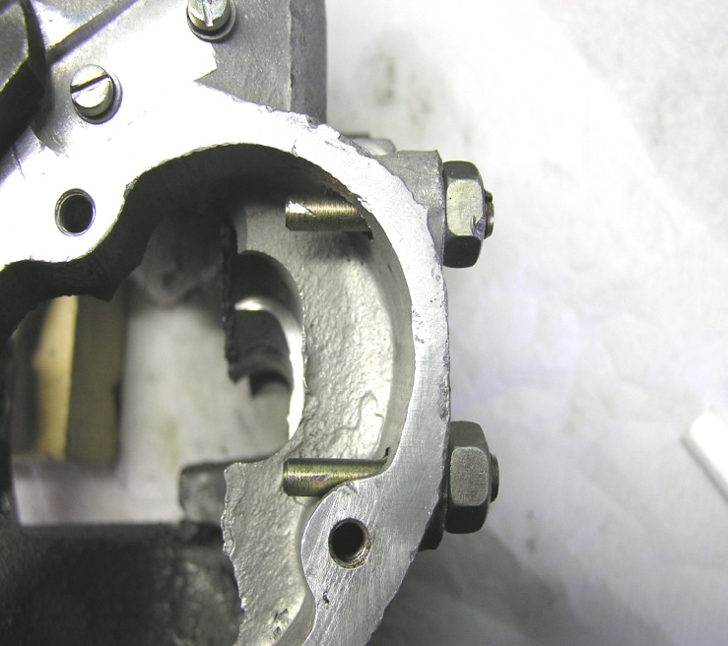
The shifter detent is a spring loaded metal ball that engages notches in the edge of the shifter cam plate. The detent unit is pressed into the transmission case. To check it simply press the ball with your fingers to make sure that it is free and moves smoothly. | 