Fitting Chang panniers

I recently purchased some leather panniers for my M1 off Beijing Ben. They fitted on quite easily and I am very happy with them.

Here is how I fitted them.

I am a little anal so I gave the metal work an extra coat of paint to reduce the likely hood of rust, and a leather treatment to the panniers to keep them soft & water repellent. The mounting frames that fix to the bike were pre drilled, but all other holes were not. I got the 6 bolts with 12 mm loc nuts & 12 washers to hold the mounting frame to the bike and the 6 smaller bolts with 10 mm loc nuts & 12 washers to hold the panniers to the mounting frame from my shed.

I was a little concened the mounting frames would rattle or the flanges would break on the welds as they were tighten up so I gel gripped in some insertion rubber & put 9.5mm fuel hose on the bolts so the mounting frames were a snug fit when mounted on the parcel rack:

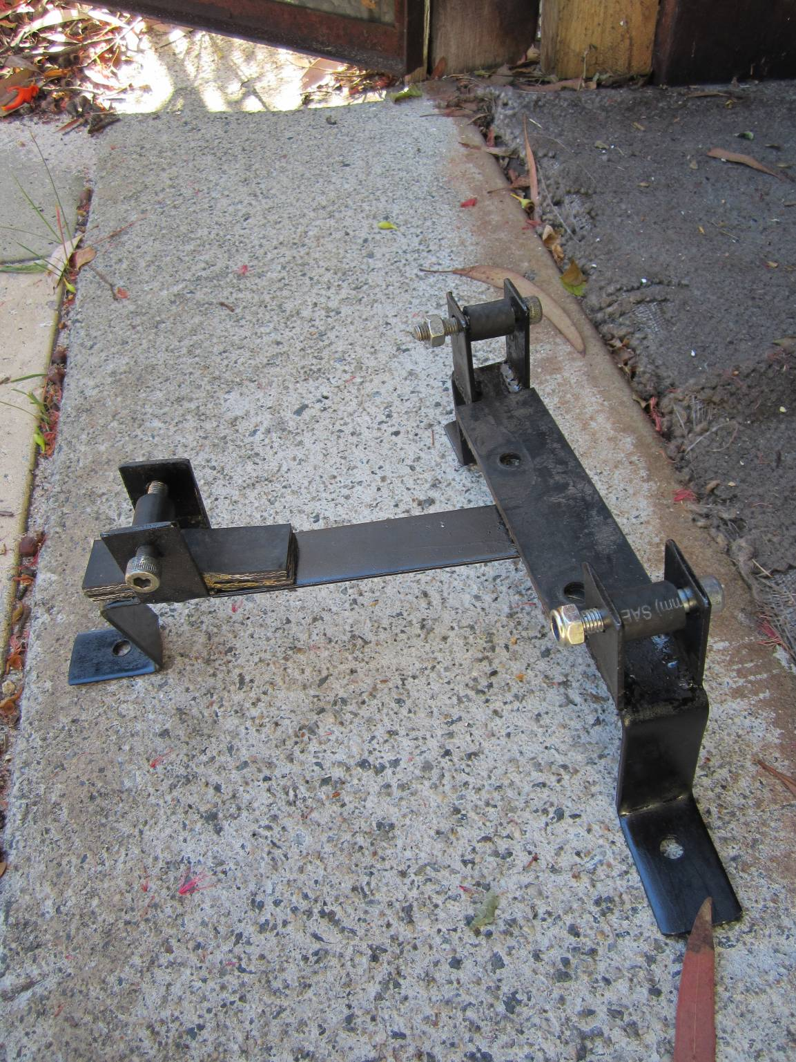
As you can see, it fits snugly even without tightening the bolts and did not rattle, so I tightened the mounting frames in place.

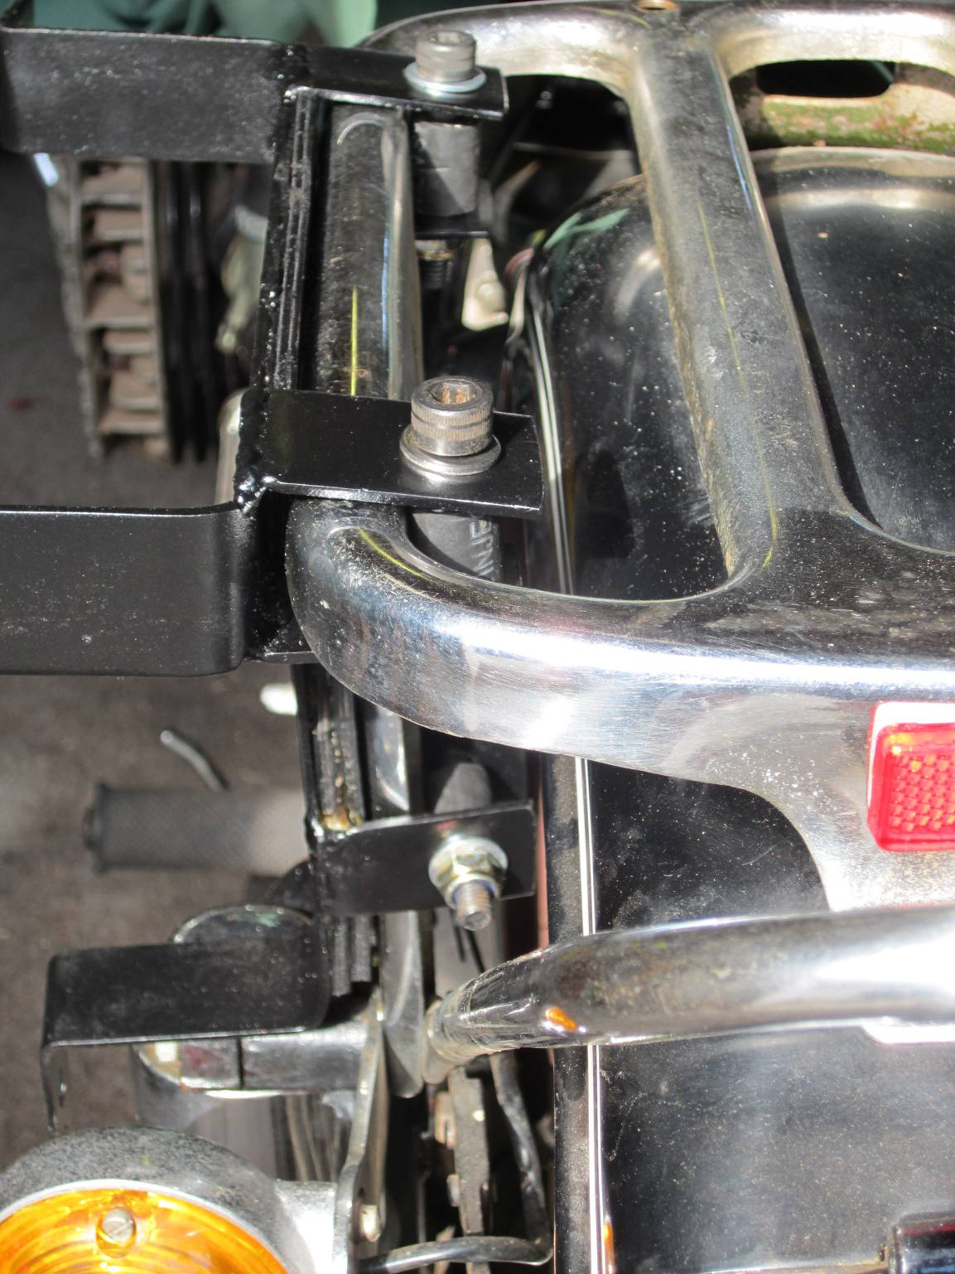

Next, I clamped the pannier internal frame to the mounting frames with mole grips (vise grips) and marked the holes that were pre drilled on the mounting frames onto the pannier frames. When I first tried this I had the pannier frame up side down, so the panniers were high – the extra bar should be at the bottom. Make sure you can replicate the positioning on the other side – I lined up the front edges of the 2 frames together and let the back end sort itself out. See the indicator touching the frame – I didn’t like that. Nothing a little bendy pressure on the indicator to move it away wouldn’t fix (careful now, you don’t know your own strength big fella!)

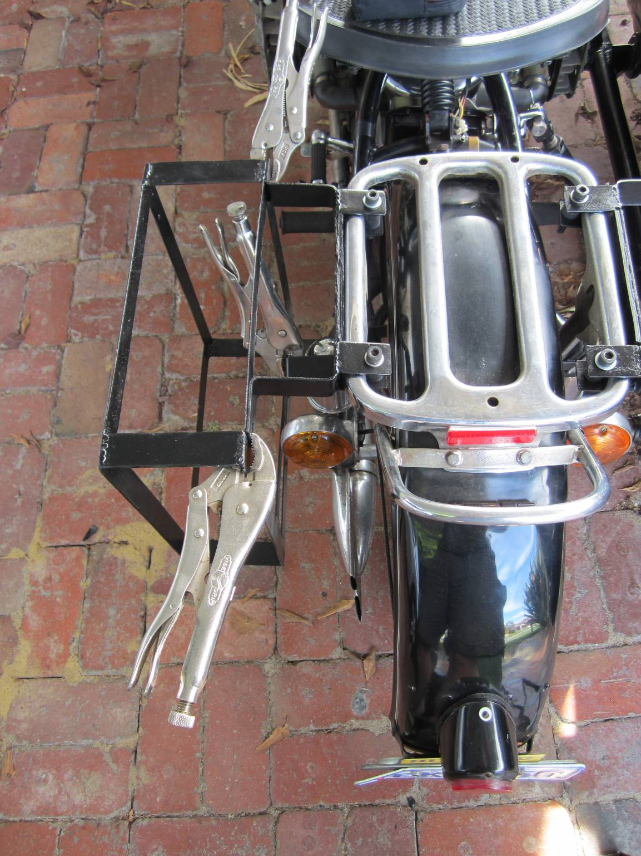

I un-vise gripped the pannier frame out with my markings on and pilot drilled the holes before drilling them out to the same size as the holes on the pannier mounting frames. Pic below shows my white paint pen marking with the pre drill hole in the centre.

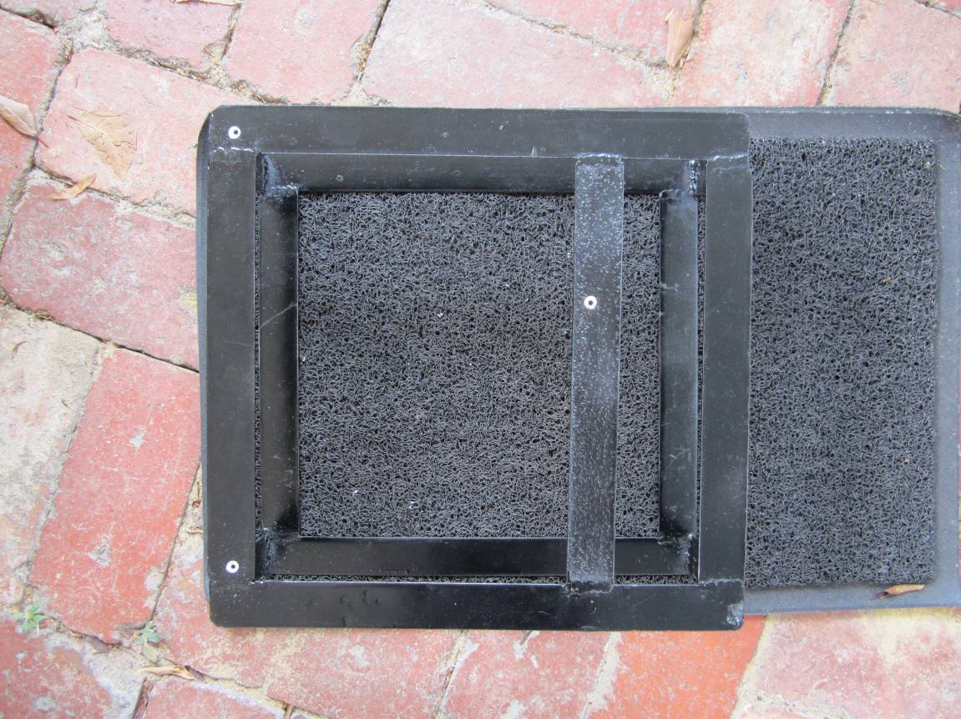

I put the frames in the pannier (right way up pls – 2 holes at the top) and marked the holes inside the panniers. I removed the frame for drilling. Drilling the top 2 holes was easy – I could twist the leather so my drill could get inside where the marks were. The 3rd hole was more awkward. I poked an awl through to mark the where the hole should be on the pannier then drilled the leather from the outside. I then screwed my bolts through the holes (with washers of course). The screws tended to stay in place.

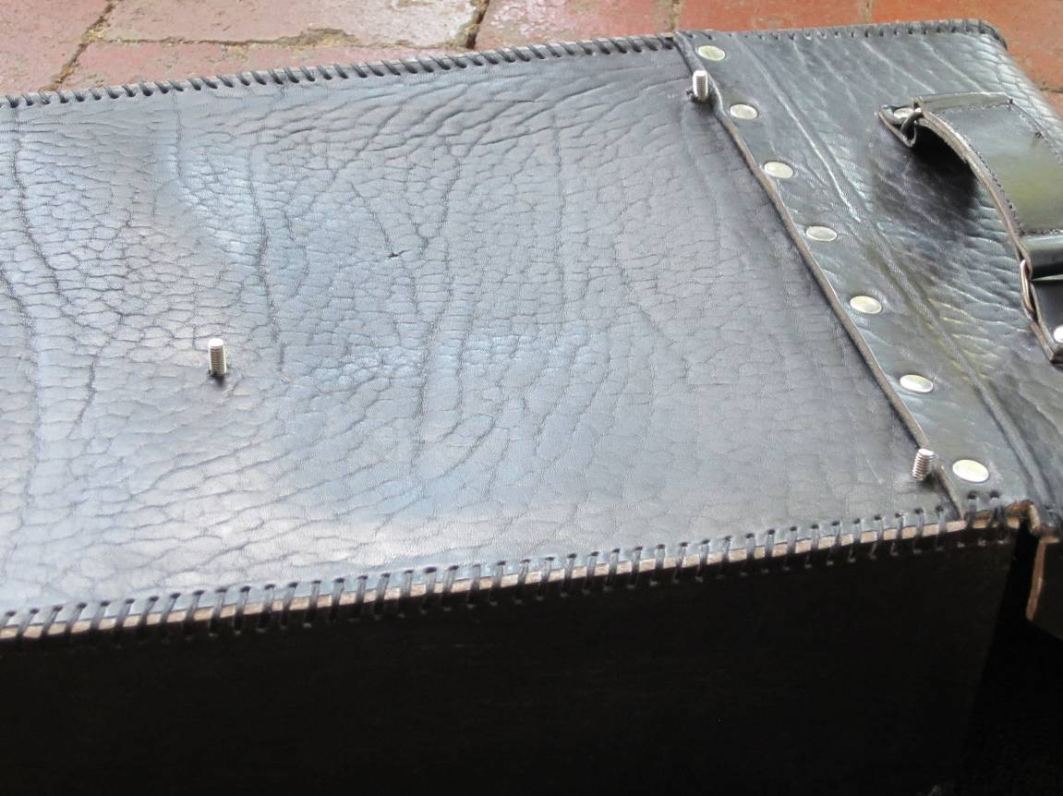

Next you find out how accurately you drilled all those holes! Luckily mine were quite close with a bit of wiggling. As you tighten up the bolts it pulled everything nicely into place. You can just see the bottom bolt in the picture below, the right hand is bolt is clearly seen, but the left side bolt is under that piece of steel. Looks good doesn’t it! But don’t get too excited – you have to repeat it on the other side. And chances are there is a sidecar in the way. But it won’t take you long the second time.

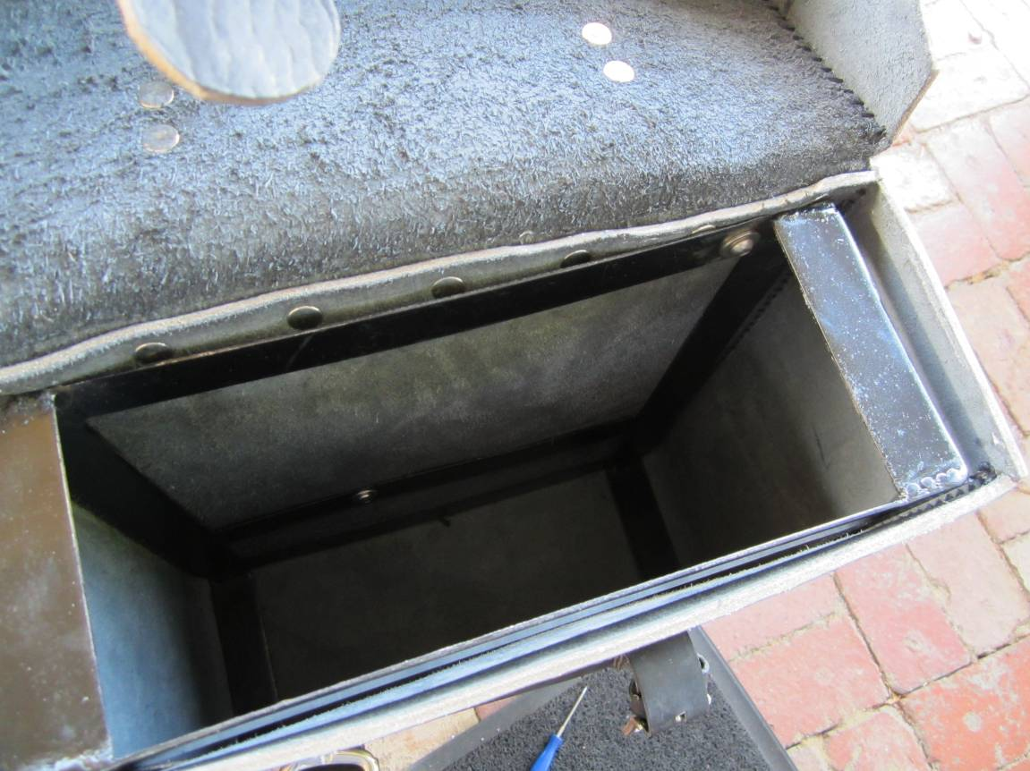

Note that the flanges on the frames are now tightened up and have pulled together, but with no sign of breaking or cracking – maybe my insertion rubber & fuel hose was for nothing? Who cares, it is done, and will reduce the chance of rattling!

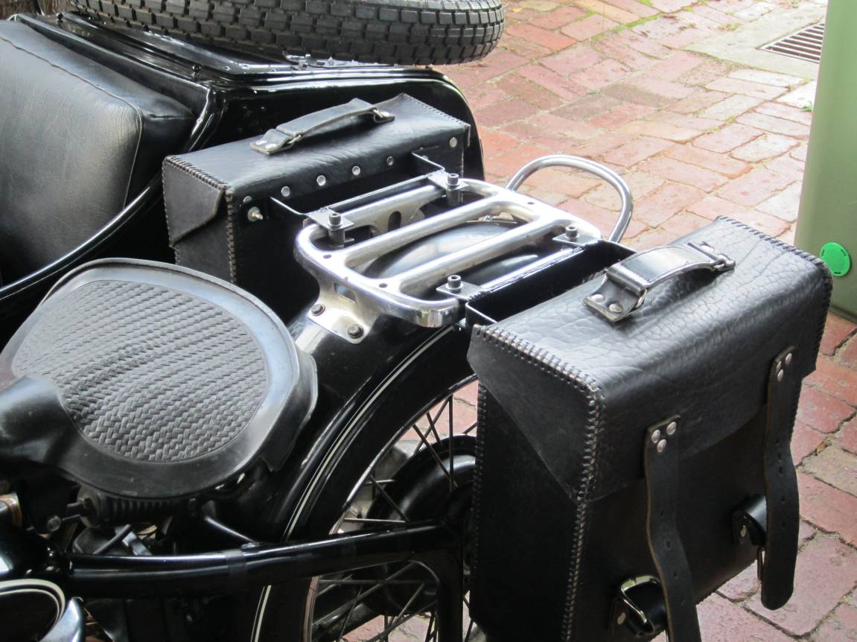

Unfortunately all those bolts on the parcel rack look ugly (above). Fortunately the pillion seat I have still fits on top & hides them all.
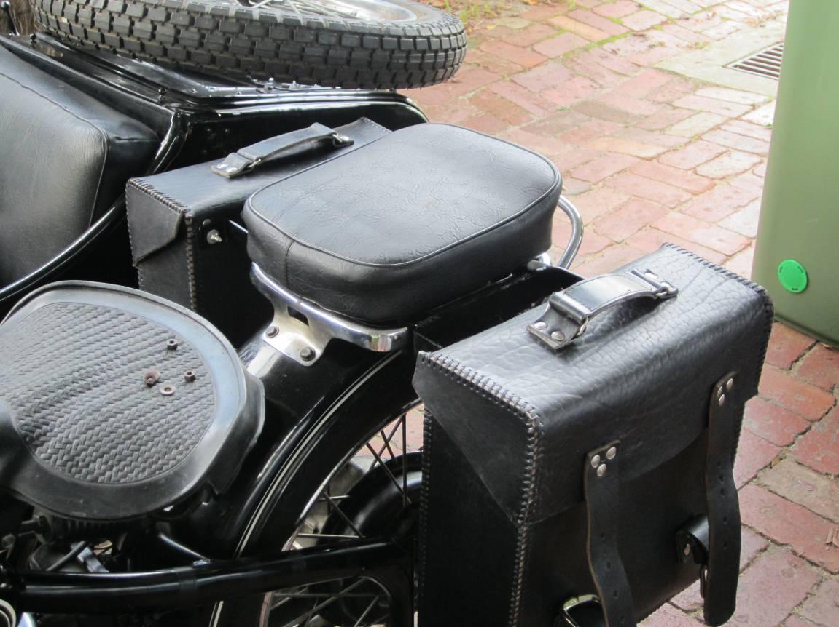

What a good afternoon’s work. I think I deserve a beer.

Best wishes from Bill in Western Australia
(1972 6V M1 with RHS sidecar)

